# Exercises: Deployment to Cloud

Exercises for the ["Containers and Clouds"](https://softuni.bg/trainings/4332/containers-and-cloud-september-2023) course @ SoftUni

## Create WordPress Site Using Azure Portal

Our task now is to create a WordPress **site** **in** Azure. WordPress can be run on a **few different Azure services**: AKS, Virtual Machines, and App Service. Let's **deploy out first WordPress site** to Azure App Service with Azure Database for MySQL **–** Flexible Server.

### Step 1: Create the Site

Go to Azure Portal on <https://portal.azure.com> and **log in**. Then, in the **search box**, type "WordPress" and select [WordPress] from the **Marketplace**:

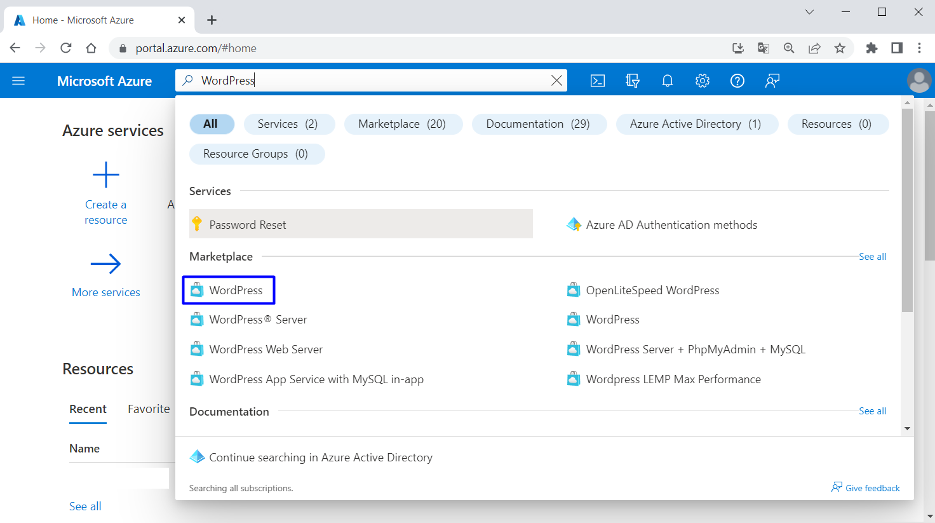

You should be on the "Create WordPress on App Service" **page**. For your convenience, you can follow this link: <https://portal.azure.com/#create/WordPress.WordPress>

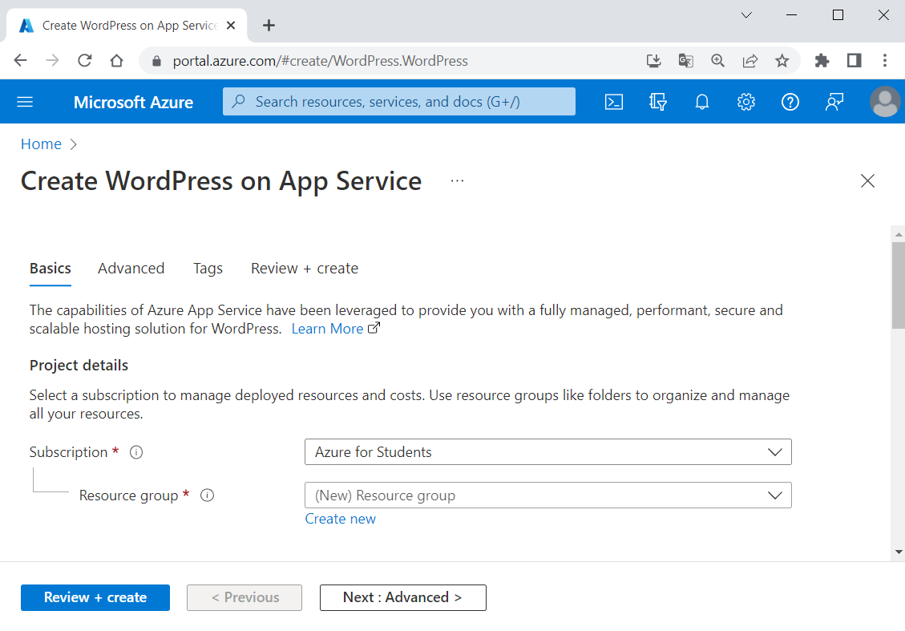

In the "Basics" **tab**, under "Project details", make sure the **correct subscription is selected** – "Azure for Students":

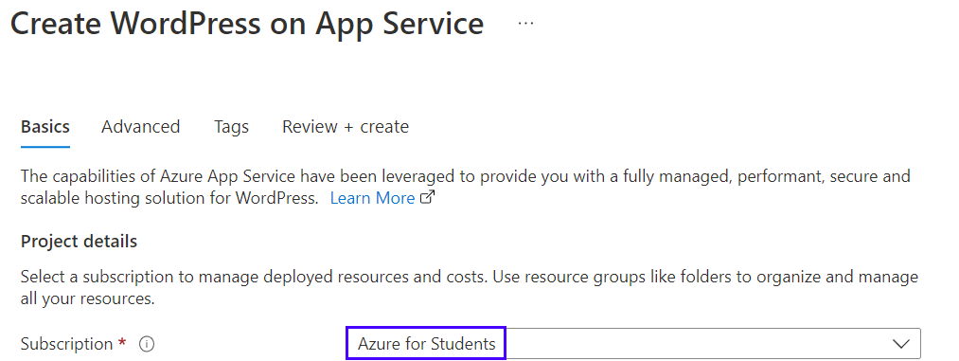

Тhen choose to [Create new resource group]. Type "WordPressResourceGroup" for the **name**:



Select a **region** near you that you want to **serve your app** from:

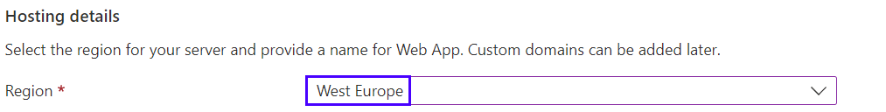

Provide a **name** for the Web App, which should be **unique**. You can name it "wordpressapp*{your name}*":



Select [Basic] for **hosting plan**:

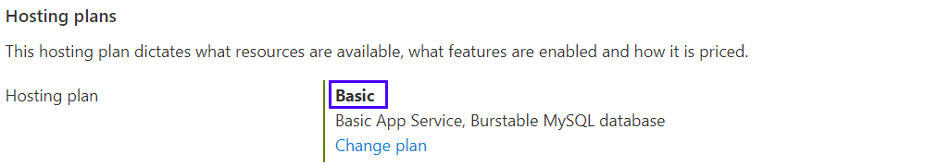

Under "WordPress Settings", type an **admin email**, **admin username**, **admin password** and **admin confirm password**. The **admin email** here is used for **WordPress administrative sign-in** only:

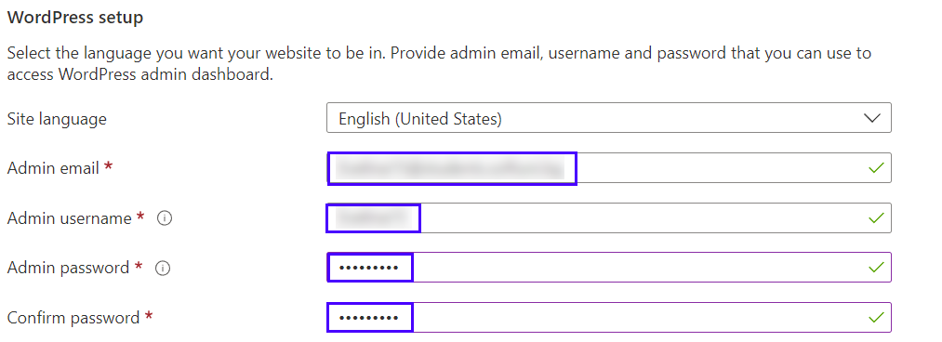

**Remember your** **credentials** for later. Then click on [Review + create]:



Click on [Create] to **create the resources**:

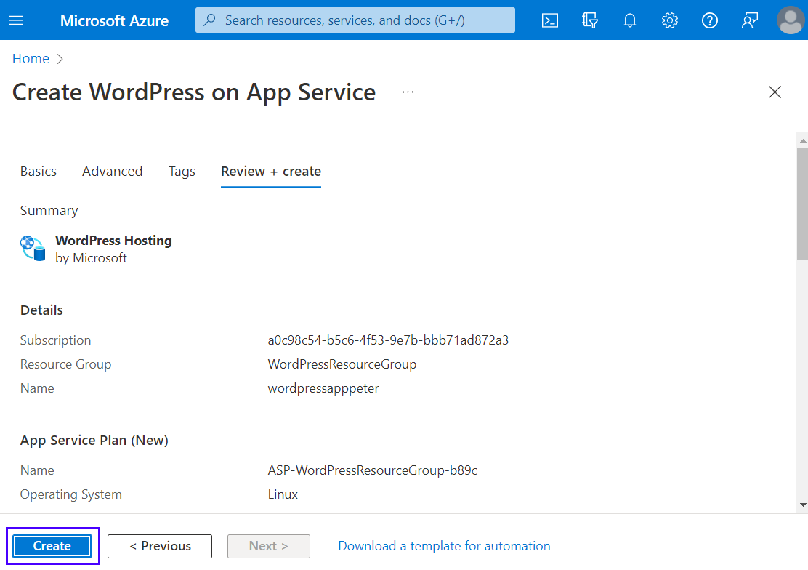

Then **wait for the deployment** to finish and click on the [Go to resource] **button**:

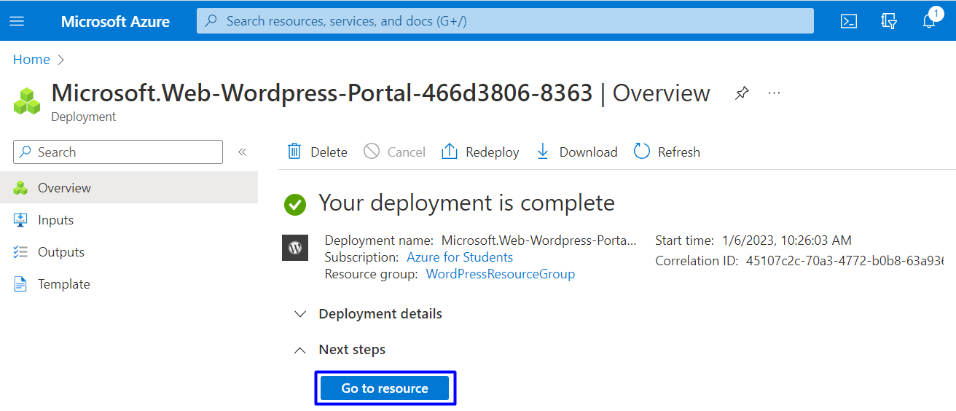

### Step 2: Browse Site

You can **click on the URL** of the site in the "App Service" **page**, in the [Overview] **tab** to access the site:

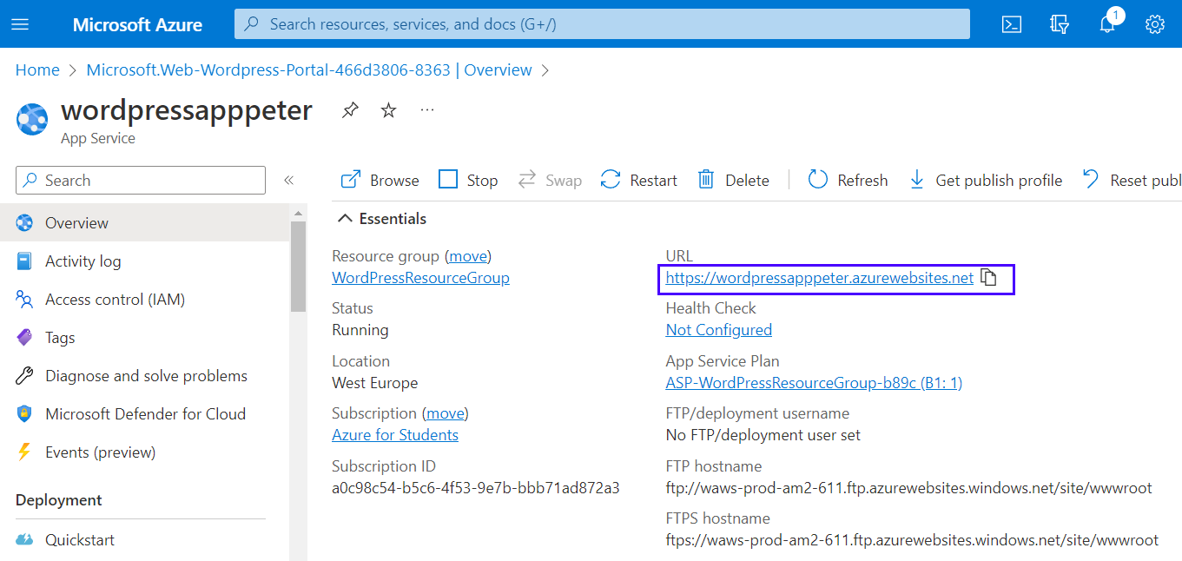

Or you can also **navigate directly** to https://<app-name>.azurewebsites.net.

Your **site needs time to** **install**. **Wait** for it:

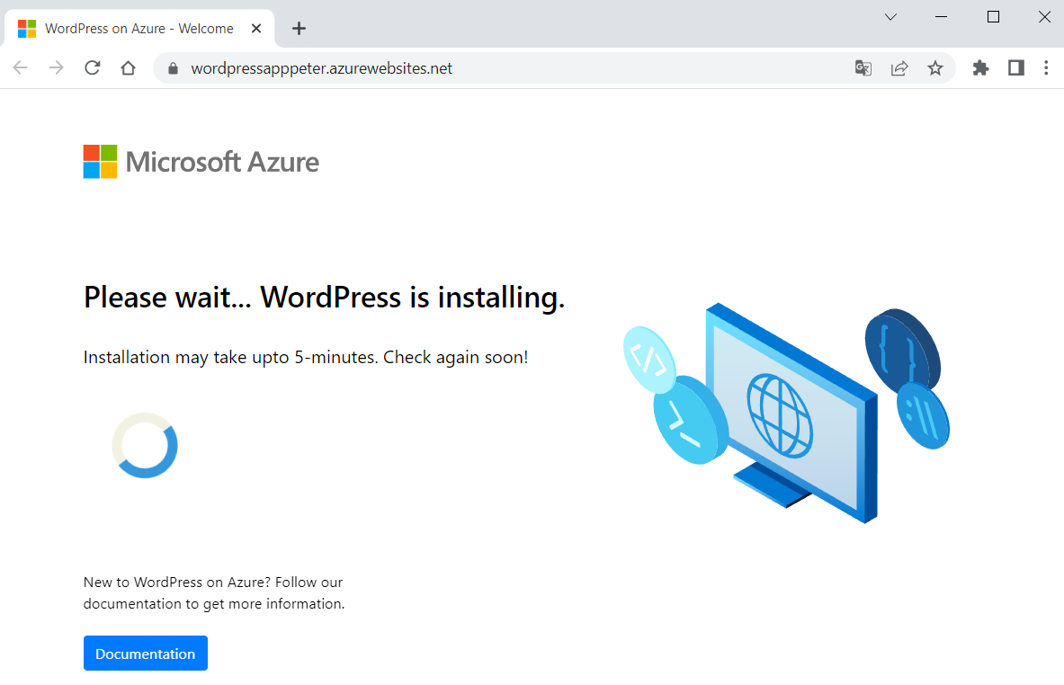

When ready, verify the **app is running properly**. If you **receive an error**, allow a few more minutes for the site to load and then **refresh the browser**.

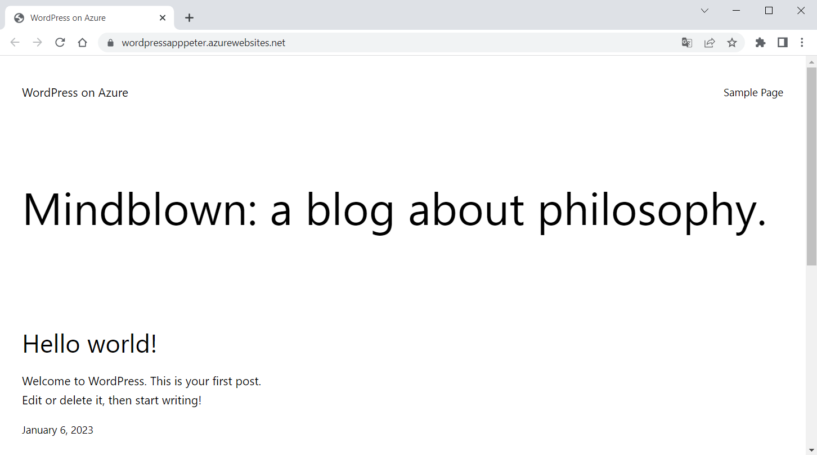

To **access the** WordPressAdmin **page**, browse to /wp-admin and **use the credentials** you created in the "WordPress Settings" **step**:

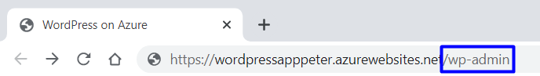 🡪

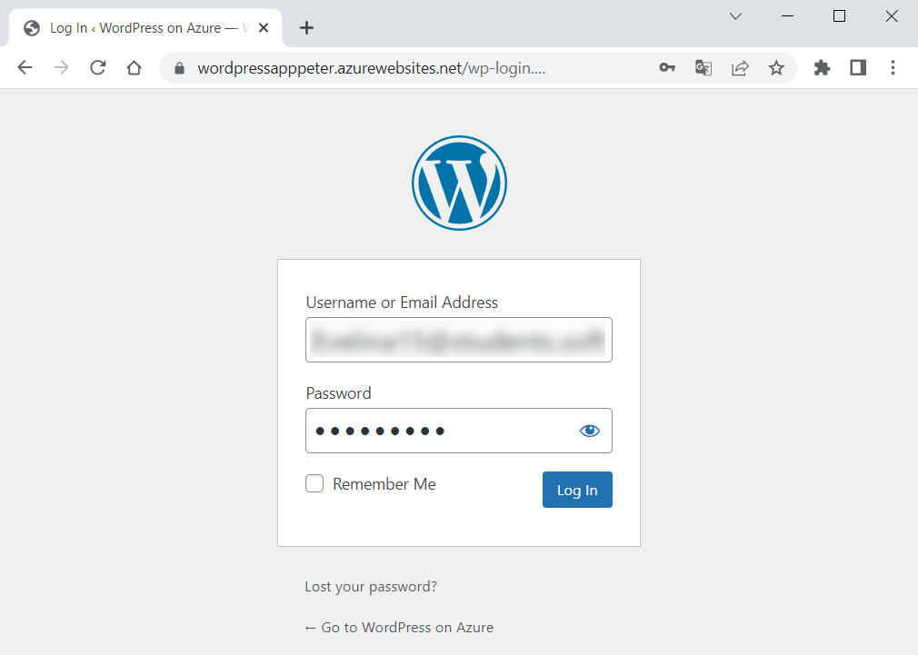 🡪

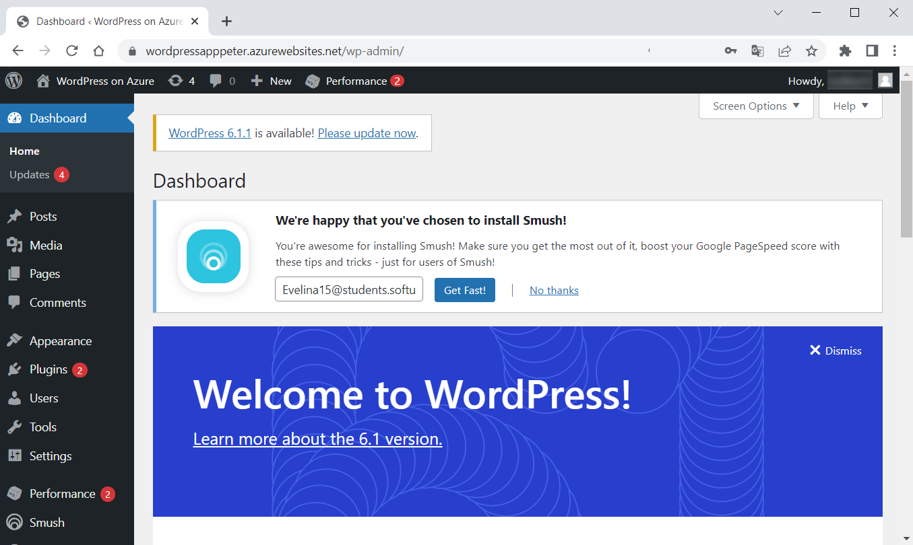

### Step 3: Access the Database

You can also **access the** MySQLFlexibleServer **database** but **not directly** because it is created behind a **private Virtual Network**.

To **access or manage the database**, we should first **get its credentials**, which are **generated automatically**. To retrieve these values after the deployment, go to "Application Settings" **section** of the "Configuration" **page** in Azure App Service and **copy the values** of DATABASE_USERNAME and DATABASE_PASSWORD:

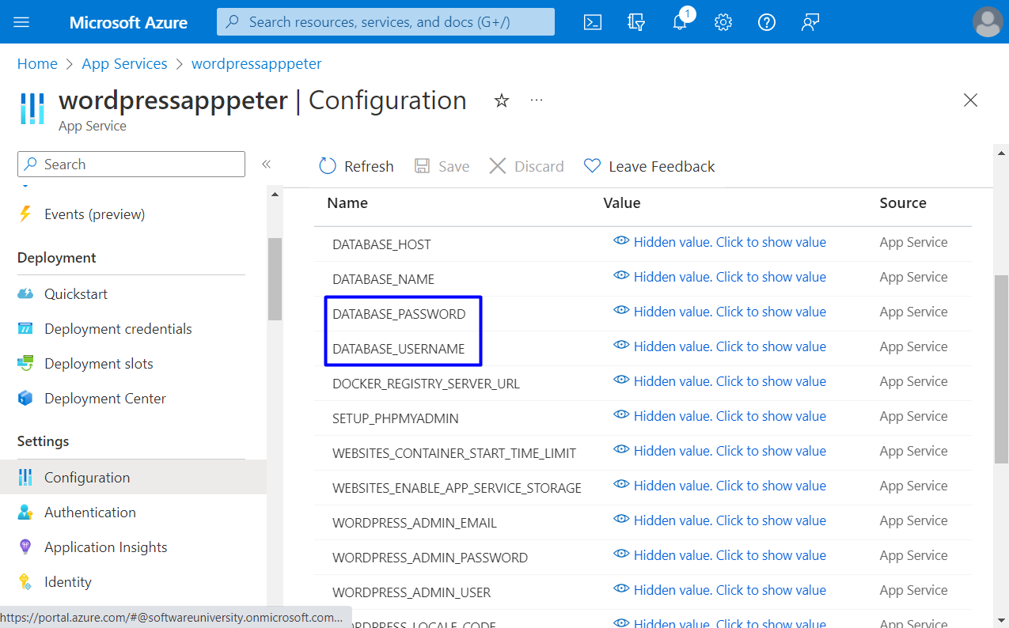

**Access the database** by using phpMyAdmin that's deployed with the WordPress site: navigate to https://<sitename>.azurewebsites.net/phpmyadmin and **log in with the credentials**:

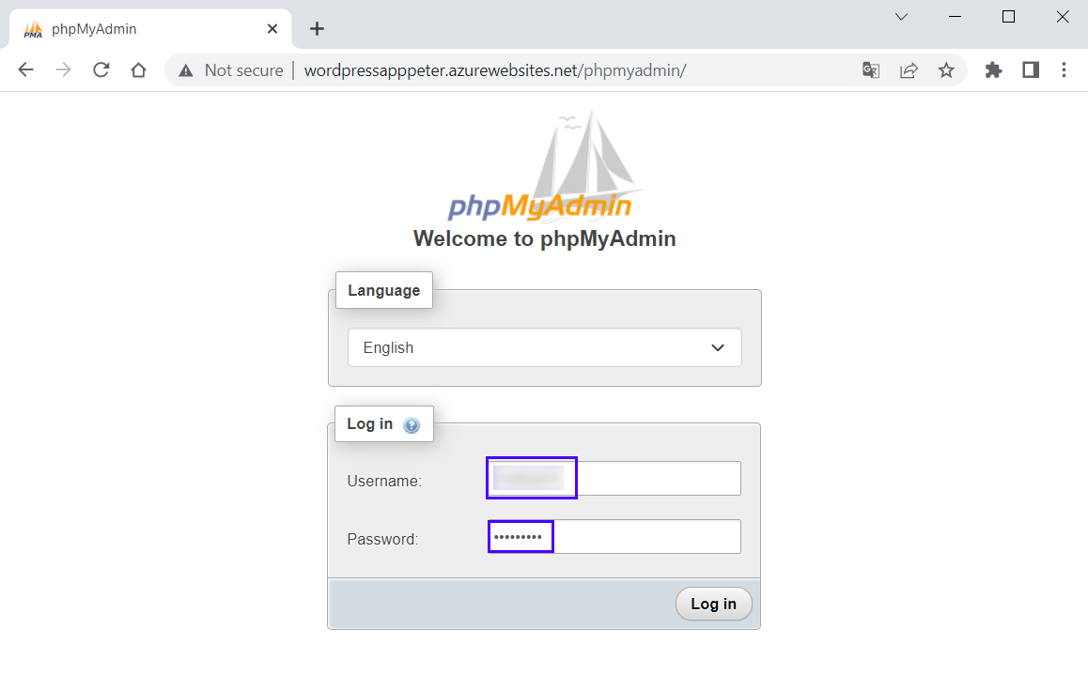 🡪 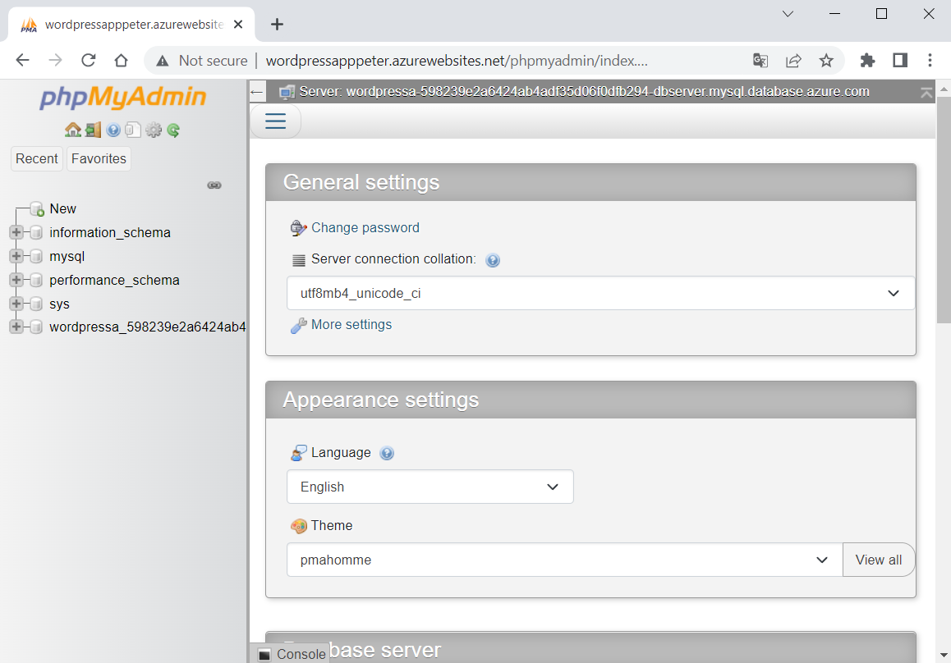

You can **explore the database** and its **tables**.

### Step 4: Explore App in Azure Portal

In Azure Portal you can **see and manage all app resources** that you created.

Look at the **resources** on the "All resources" **page** (you can search for it in the **search bar**):

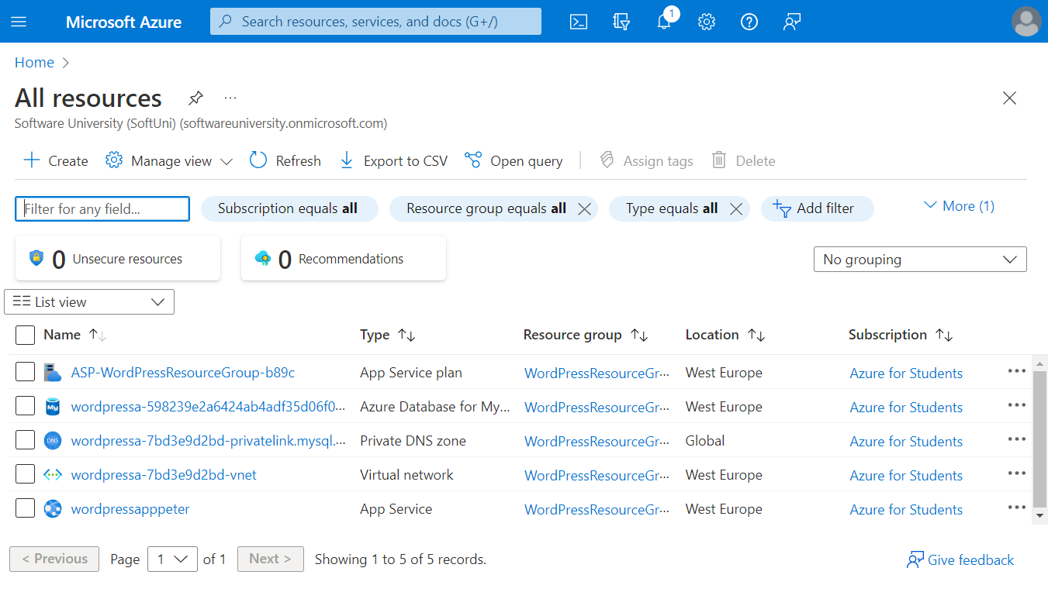

Look at each of resources and **explore** Azure Portal.

### Step 5: Delete App and Clean Up Resources

When you have successfully **uploaded your app to** Azure and **don't need it anymore**, it is time to **remove it**.

You can **delete all of the app resources** from your Azure **subscription** by **deleting the resource group**. Find **all resource groups** by going to Azure Portal and typing "Resource groups" in the **search bar**:

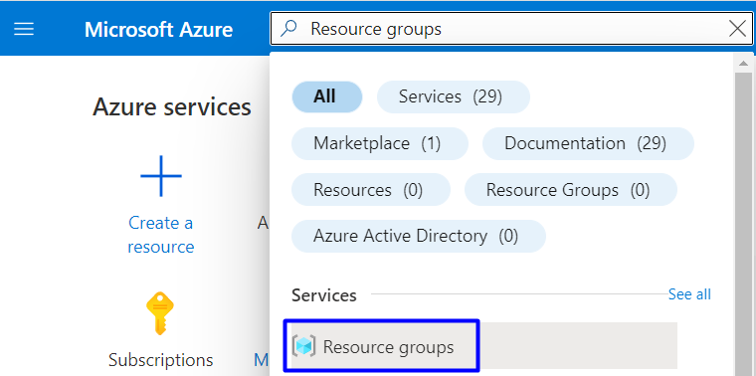 🡪

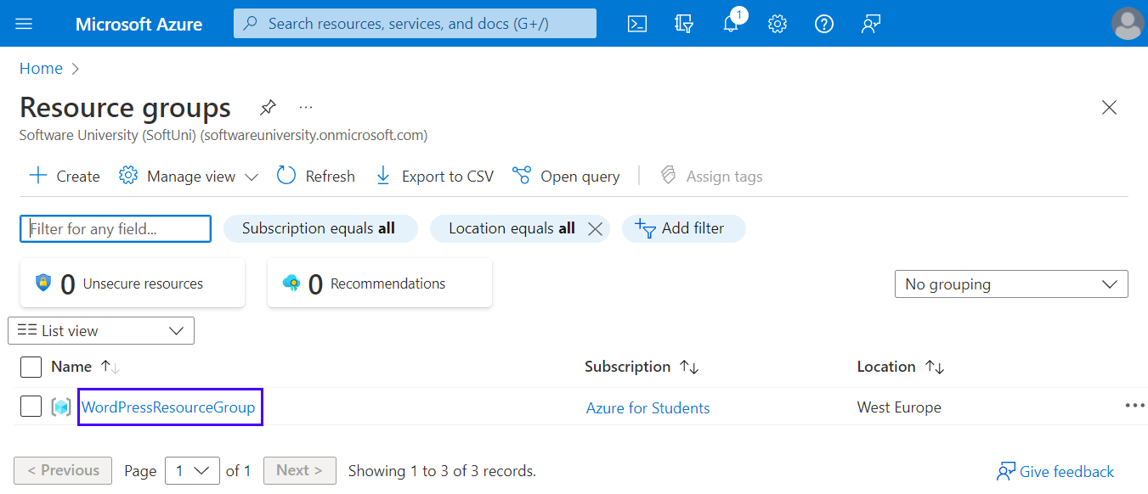

You have your "WordPressResourceGroup" **group**. Delete it by selecting [Delete resource group]:

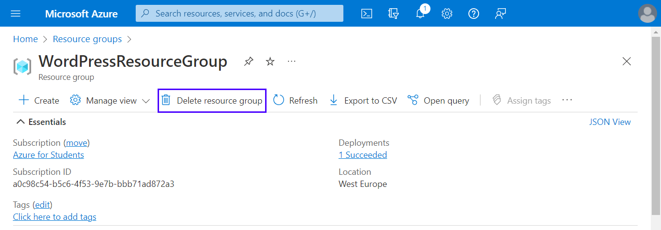

Next, type the **resource group name** and click [Delete]:

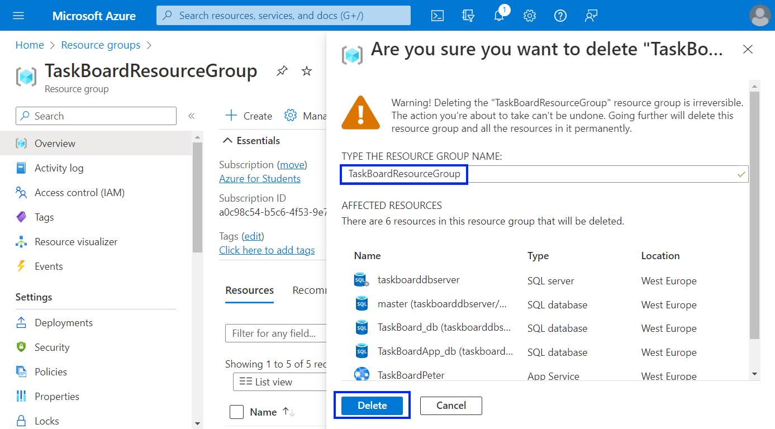

The **resource group** will be **deleted** after a while. All **resources of your app** will be **deleted** with it.

Now you have a **fully-functional** WordPress **site** in Azure and you know how to **manage it and its resources**.

## Deploy a Node.js + MongoDB Web App to Azure

You are provided with a Node.js **app** with a MongoDB **database** called "TODO App" in the **resources**. It looks like this when **run**:

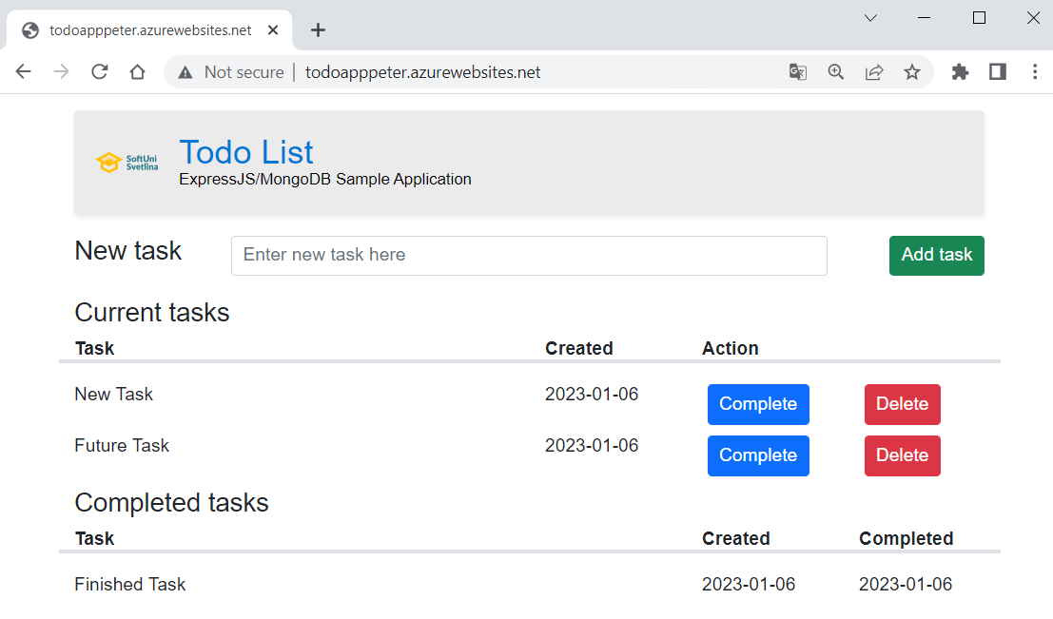

You should **upload the app to** GitHub, as a start, and then **deploy it to** Azure, using Azure App Service and Azure Cosmos DB for MongoDB.

The **process** is pretty similar to **deploying an ASP.NET app with a SQL database** – the only difference is the **settings of the app**.

### Hints

You should fulfill the below **steps** to **run the app in** Azure:

1. Upload the "TODO App" **project** **code** from the **resources** to a GitHub **repository**.

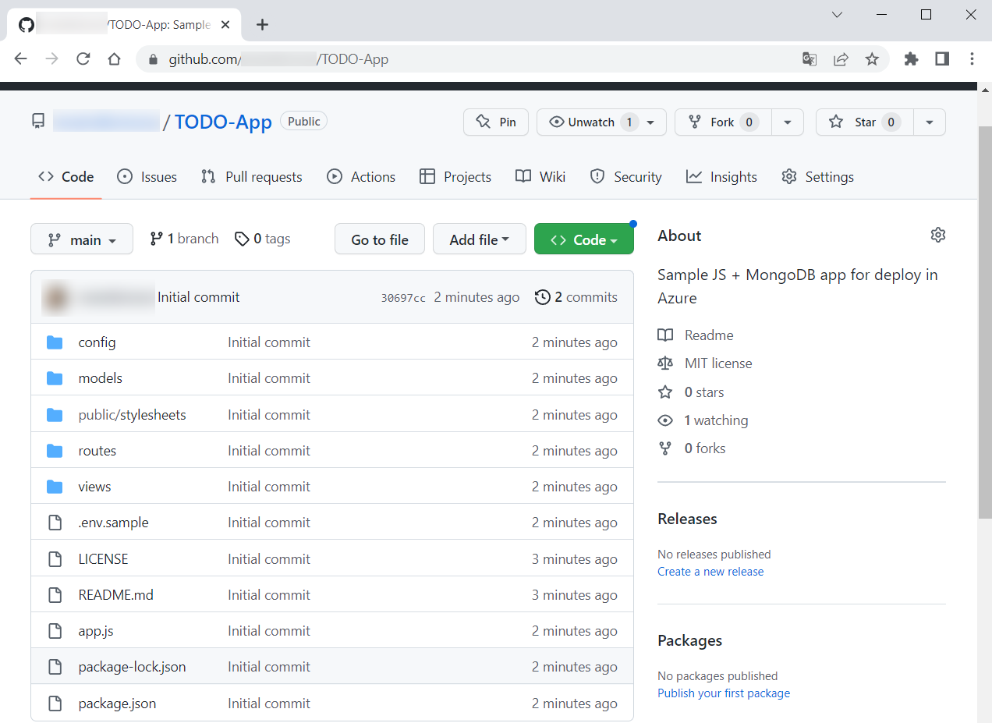

1. In Azure Portal, go to the "Create Web App + Database" **page** and **fill in the fields**. Create a **new resource group**. Give a **suitable name** to the Azure app. Choose [Node 18 LTS] as **runtime stack**. Don't change the **default selected database engine** (Cosmos DB **API** for MongoDB) and **copy the generated database** **name** because you will need it later.

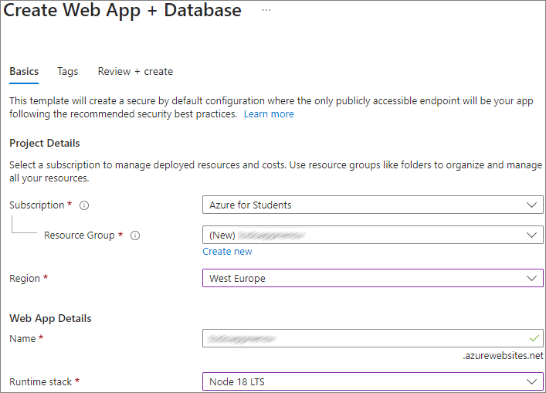

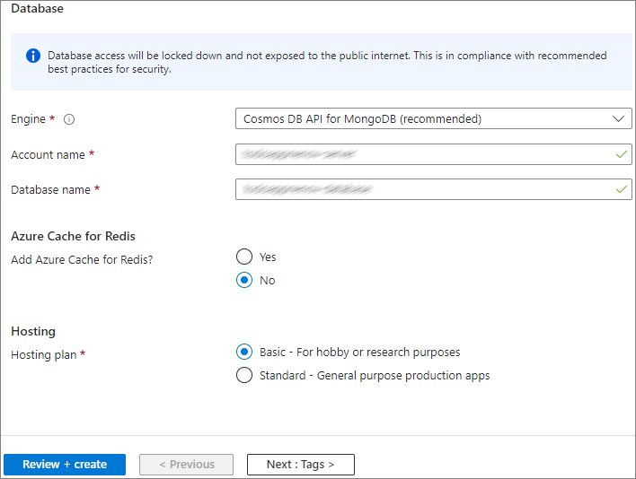

1. Go to the "Configuration" **page** of the App Service **app** and create a [New application setting] with:
   * **Name**: "DATABASE_NAME"
   * **Value**: the automatically **generated database name** you copied earlier (i.e. <app-name>-database)

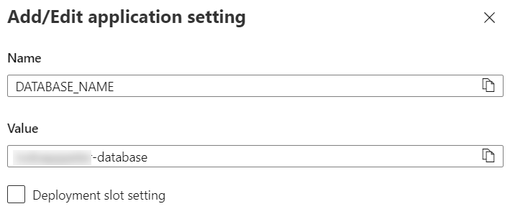

1. Next, select the "MONGODB_URI" **connection string** on the same page and **copy its value**

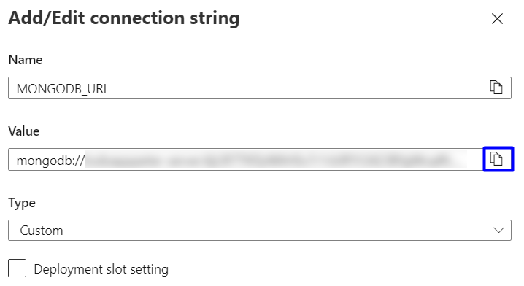

1. Create one more **new application setting** with:
   * **Name**: "DATABASE_URL"
   * **Value**: the "**MONGODB_URI**" **connection string** you copied earlier (i.e., mongodb://...)

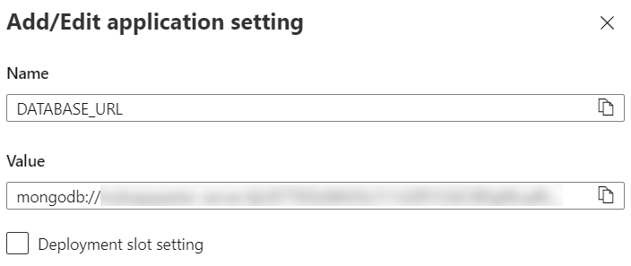

Don't forget to **save the settings**.

1. Your app is configured to work with the **Azure database**, so you should just go to the "Deployment Center" **page** and **deploy the app** from the GitHub **repository**.
2. A GitHub **workflow** should be created and it should **show a status of "**Complete". It takes about 15-30 minutes.
3. You should be able to **access the app** on https://<app-name>.azurewebsites.net and **work with it**.

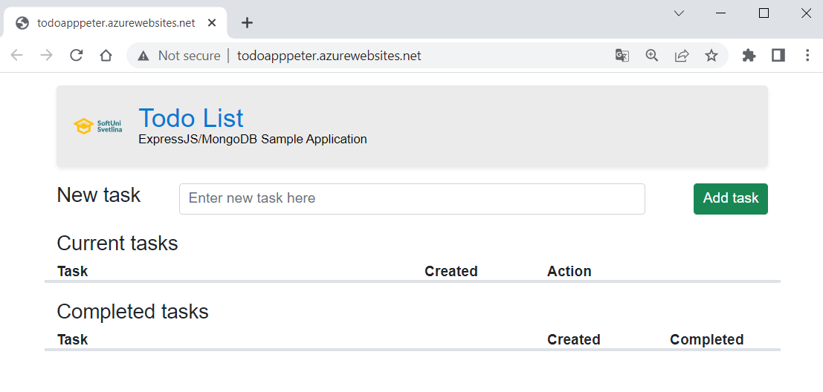

**NOTE:** Don't forget to delete the resources in your Azure account.

## Deploy NGINX Server Container to Azure using Azure Portal

In this task, we will **deploy a container instance** to Azure Container Instances using the Azure Portal. Azure Container Instances allows us to **run serverless and isolated Docker containers** in **Azure** and make its application available with a **fully qualified domain name** (FQDN).

We will use the NGINX **server** **image** from DockerHub: <https://hub.docker.com/r/nginxdemos/hello>. You are already familiar with the **server**. When **deployed to** Azure, it will look like this:

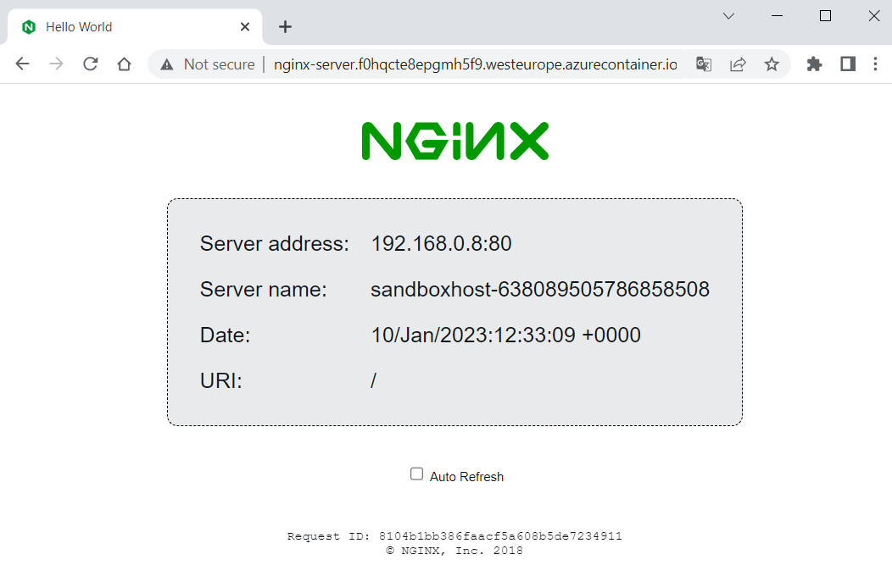

Let's see how to do this. As a first step, open Azure Portal (<https://portal.azure.com>) and **click on** [Create a resource]:

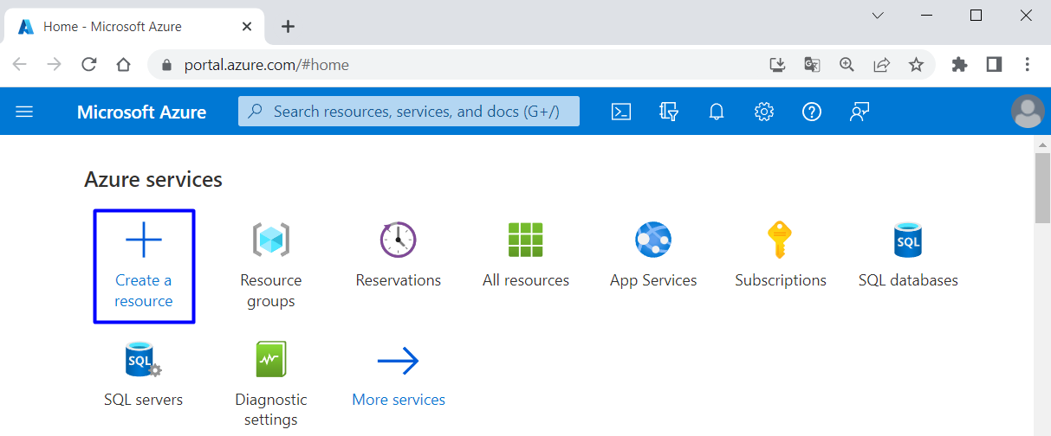

Next, choose [Containers] 🡪 [Container Instances]:

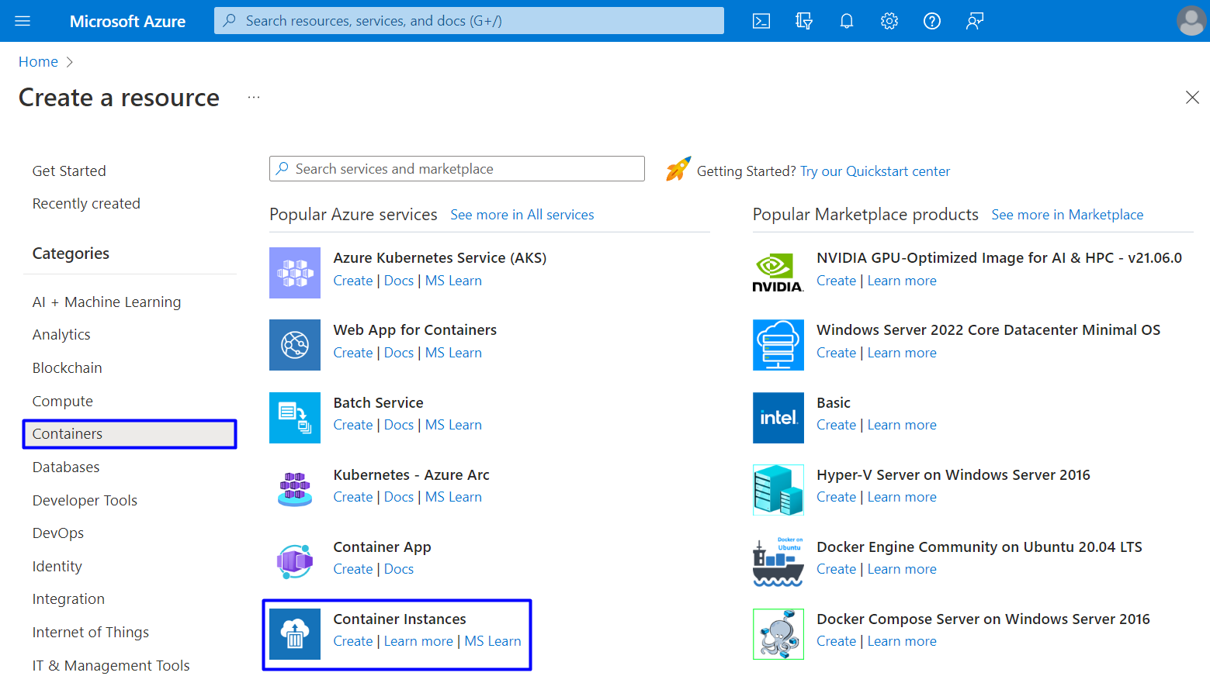

On the "Basic" **tab** of the "Create container instance" **page** you should **fill in the fields** as follows:

* Use your "Azure for Students" **subscription**
* Create a **new resource group** with a suitable name
* Create a **name for your container**
* Choose a **region** near you
* Leave the "Availability zones" to [None]
* For the **image source**, choose [Other registry] (to use an **image from** DockerHub, which is the **default registry** for this **option**) and **fill in the image name**
* Leave the "OS type" to [Linux] and "Size" field with the **given options**

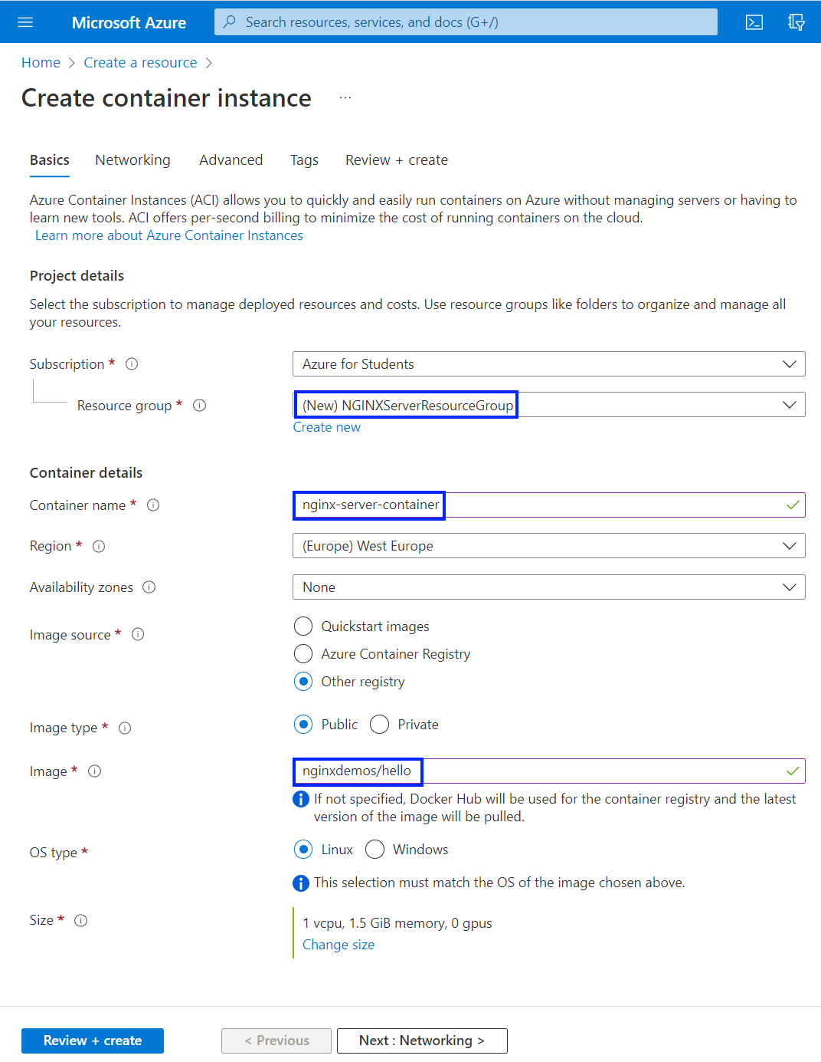



Click on [Next] to go to the "Networking" **tab**. There you should **fill in a DNS name** **for your container** and **choose** [Tenant] for **DNS scope reuse**:

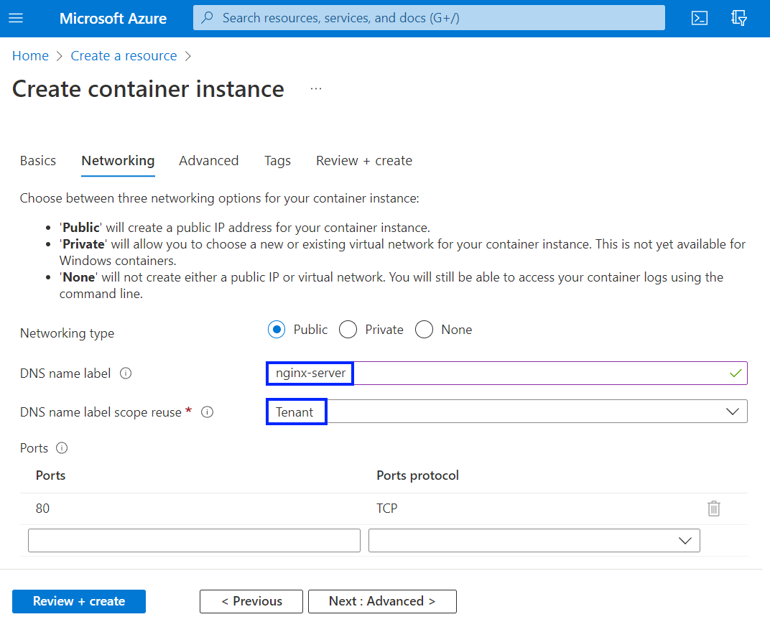

The **name must be unique** within the Azure region where you create the container instance. Your container will be **publicly reachable** at <dns-name-label>.<region>.azurecontainer.io. An **auto-generated hash** is added as a **DNS name label** to your container instance's **fully qualified domain name** (FQDN).

If you receive a "DNS name label not available" **error message**, try a **different DNS name label**.

**Leave all other settings** as their defaults and select [Review + create], then [Create]. Wait for the **deployment** **to complete**:

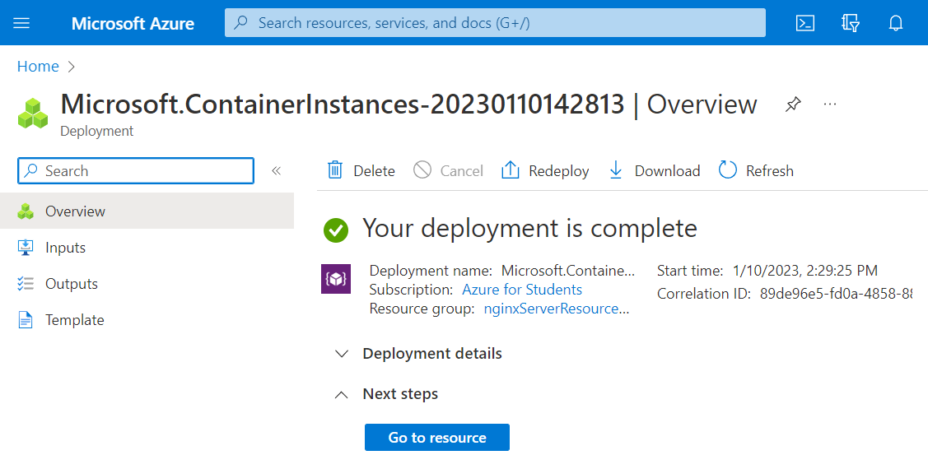

Then go to nginx-server **container instance** from the "Container instances" **page**:

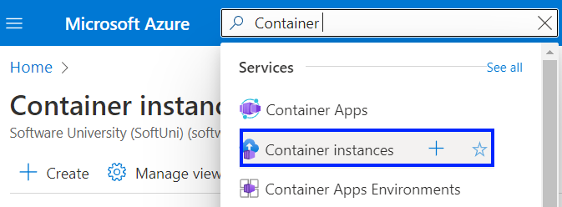 🡪 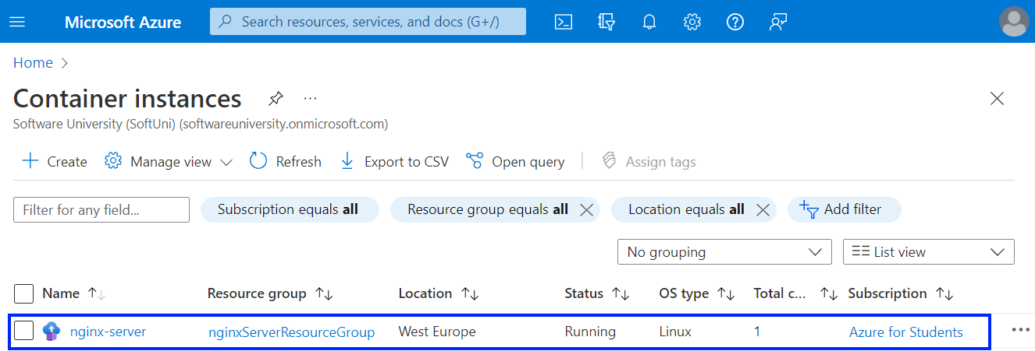

Look at the FQDN and the **status** **of the container** on the "Overview" **page**:

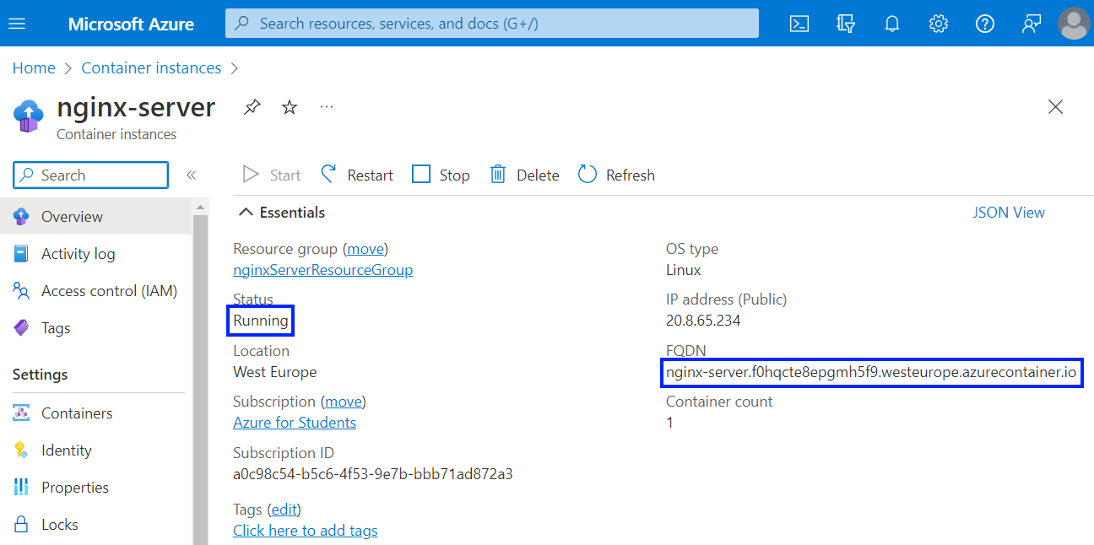

When the **status** **is** "Running", navigate to the **container's FQDN in your browser** and you should see your NGINX **server**:

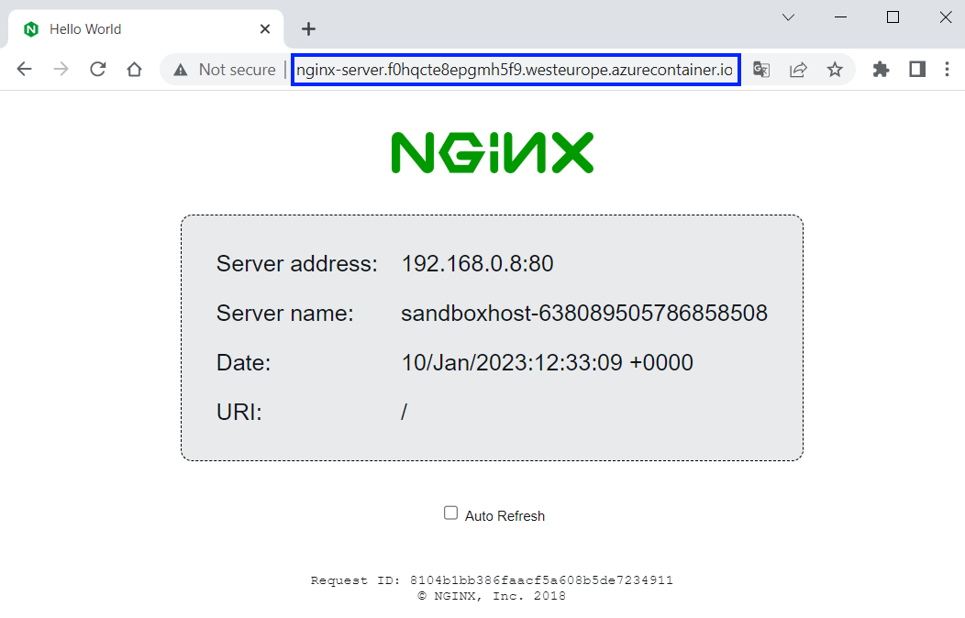

**NOTE**: if you **receive an error**, **wait for the container** a little bit more. After **up to 5 minutes**, it should be **loading** **successfully**.

If you have **any other problems**, you can look at the **container logs** in [Containers] 🡪 [Logs]:

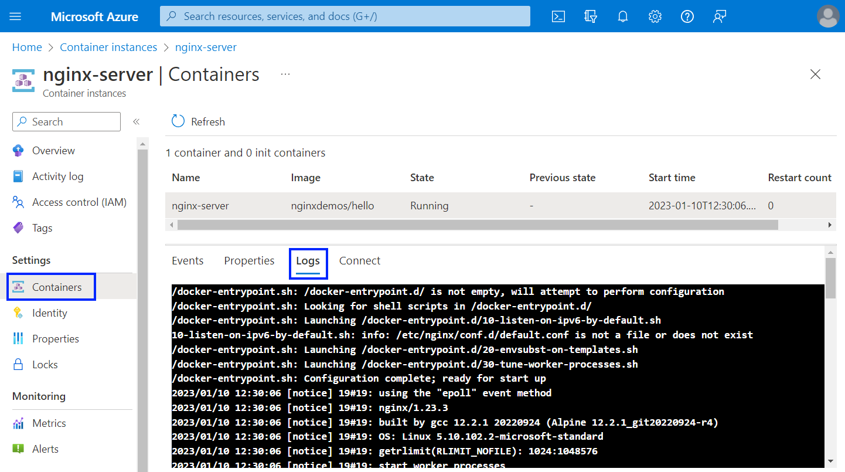

You can **delete the container** by **deleting its resource group** in the familiar to you way. You can also **delete only the container** by going to [Overview] and clicking on [Delete]:

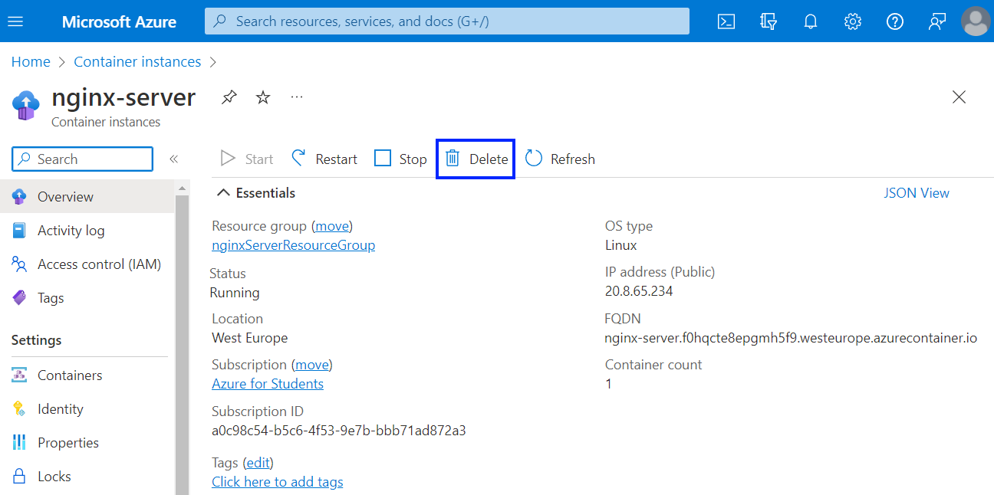

## Deploy NGINX Server Container to Azure using Azure CLI

Now we will see how to **deploy a** NGINX **server container to** Azure but using Azure CLI **commands**.

**NOTE:** Docker Desktop should be **running** in order for the commands to be executed successfully. Also, you should **open a** CLI to execute commands, for example PowerShell.

First, **log in to Azure** with the following command:



A **browser window** **for** **login to Azure** will appear. Enter your **credentials** and you should be **successfully logged in**:

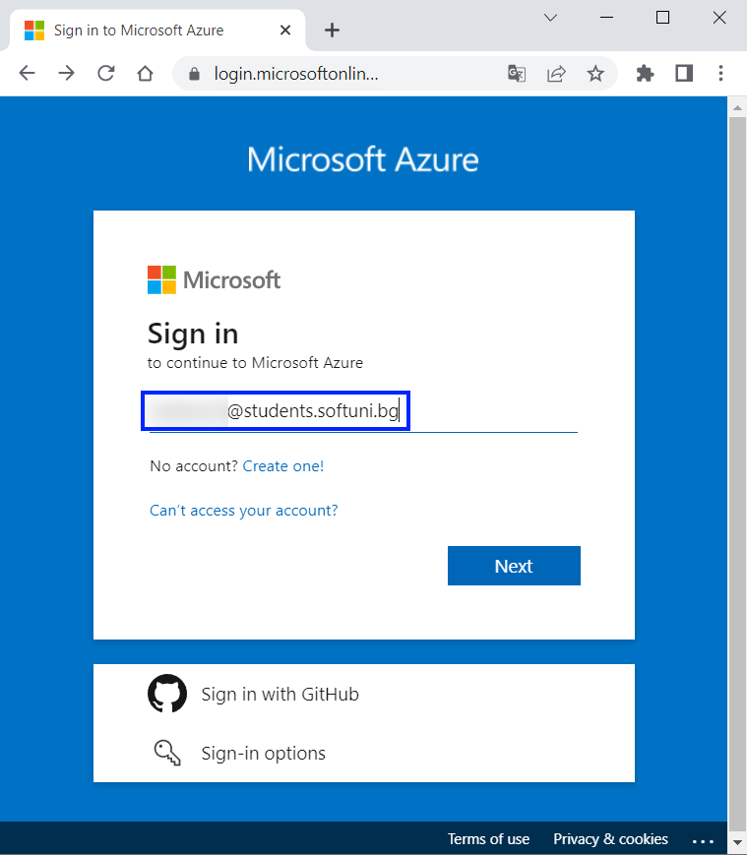 🡪 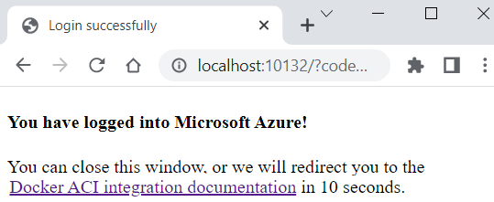

You can **close the above browser window** and **return to** PowerShell.

Next, we should **create an** ACI **context**, which **associates Docker with an Azure subscription** **and resource group** so you can create and manage container instances. Our **context** will be called "nginxacicontext":



Now you are prompted to **select your subscription** and a **resource group**. You should **choose the** "Azure for Students" **subscription** and **create a new resource group**, using the **arrow keys** and the [Enter] **key** on your keyboard.

In our case we have **only one subscription** **option** and **no resource groups**, so hitting [Enter] is enough:

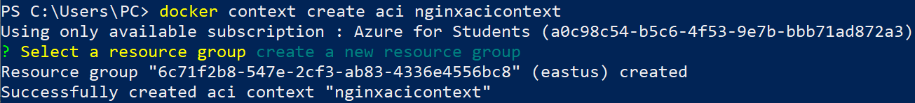

A **resource group** and an **ACI context** were successfully created. Note that the **new resource group** is created with a **system-generated name**.

Confirm that you **added the ACI context** to your **Docker contexts** like this:

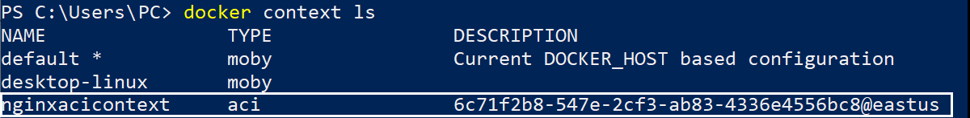

After **creating a Docker context**, you can **create a container in Azure**. First **switch to the ACI context** we created, so that Docker commands run in it:



Run a docker run **command** to **run a NGINX server container instance** in **Azure** with **exposed port 80**:

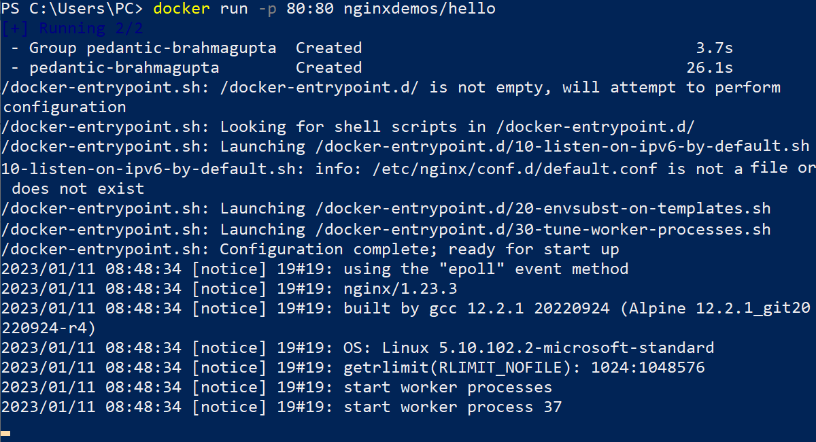



As you can see, the **name of the container** here is pedantic-brahmagupta (yours may be different). You can press [Ctrl] **+** [C] to **exit the logs**.

Then, use the following command to **see all containers** and get details about your **running container**, including its **public IP address**:



**Get this address** and **paste it in the browser** to **access your app** (its **status** should be "Running"):

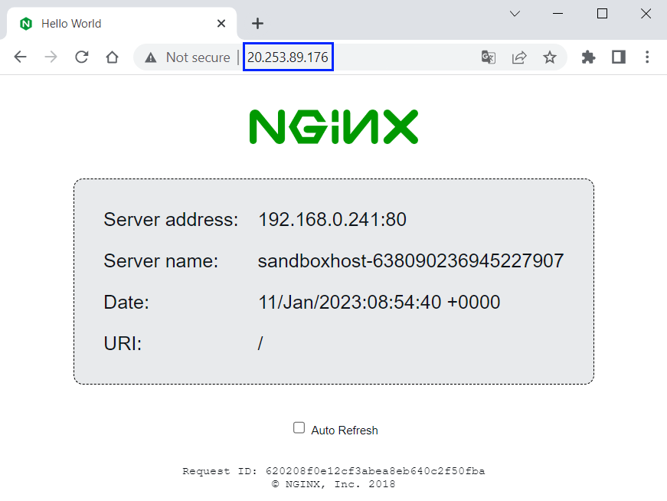

**NOTE:** it may be necessary that you **wait a few minutes** for the **container app to load**.

You can also **look at your container instance** in Azure Portal:

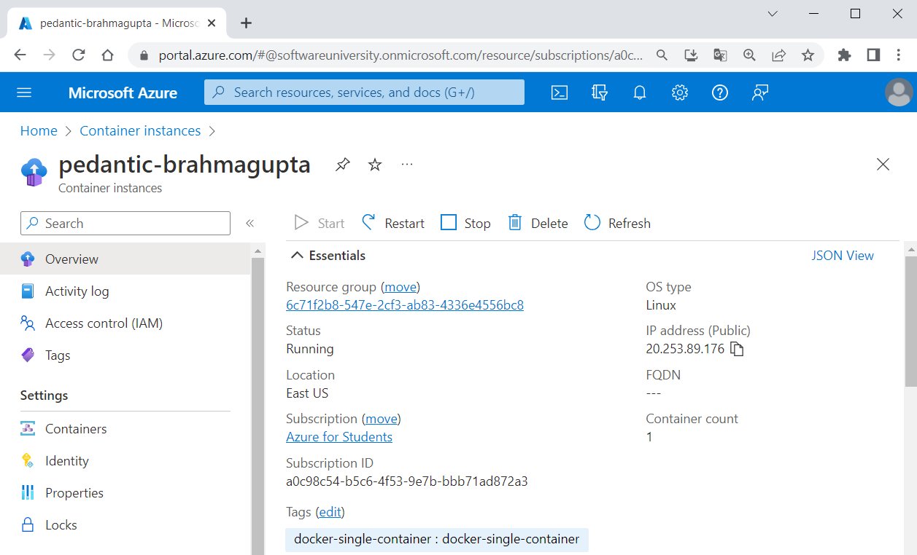

Note that in this case we **have an** IP **address**, not a FQDN.

Also, you can **pull the container logs** if you need them like this:

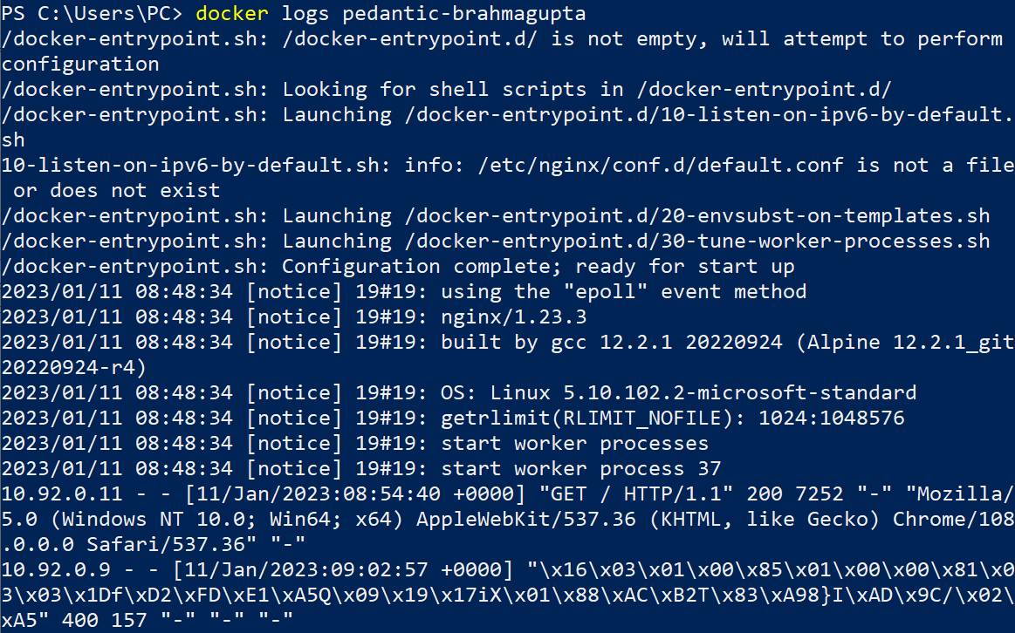

You can also **stop** and **delete the container**:



However, the **resource group should be deleted** from Azure Portal.

After this **first two tasks** you know **how to create** AzureContainerInstances using Azure Portal and Docker CLI. You could also **do it through** AzureCLI, which we will **show you in the next task**.

## Deploy the "Tracker" App to Azure

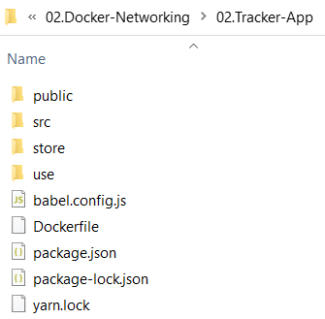Your task now is to **run** **a** **simple JavaScript front-end app based on** Vue.jsfor keeping track of daily duties in a Docker **container**. It does not need **anything but an image** to run. It does not use a database or any other storage.

You're provided with **its files** it in the **resources**, together with a Dockerfile which runs the **app on** NGINX **server** (on the right):

You should **deploy the app** to Azure Container Instances.

### Install Azure CLI on Your Local Computer

The Azure Command-Line Interface (**CLI**) is a cross-platform **command-line tool**, which can be used to **connect to Azure** and **execute administrative commands** on **Azure resources**. It can be run from **inside a Docker container**.

Because the Azure Cloud Shell does not include the Docker **daemon**, you must **install both** the Azure CLI and Docker Engine on your **local computer** for this task. We will **use it**, as well, but later when we are done with Docker.

You already have Docker, so let's **install** AzureCLI. This can be done **through** PowerShell with the following **command**:

|  |
| --- |
| $ProgressPreference = 'SilentlyContinue'; Invoke-WebRequest -Uri https://aka.ms/installazurecliwindows -OutFile .\AzureCLI.msi; Start-Process msiexec.exe -Wait -ArgumentList '/I AzureCLI.msi /quiet'; rm .\AzureCLI.msi |

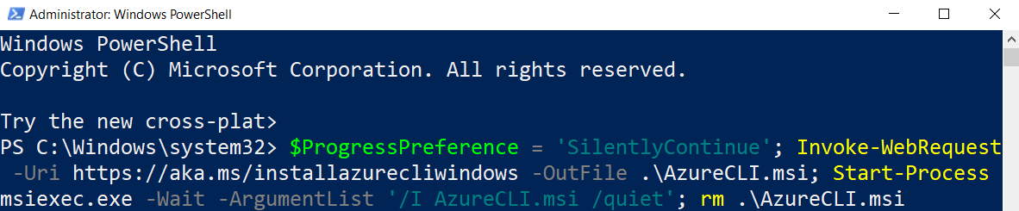

**NOTE:** PowerShell must be **run as administrator** for the **installation**. After that, run a **new PowerShell instance** in the standard way and **work with it**.

You can check your Azure CLI **version** with:

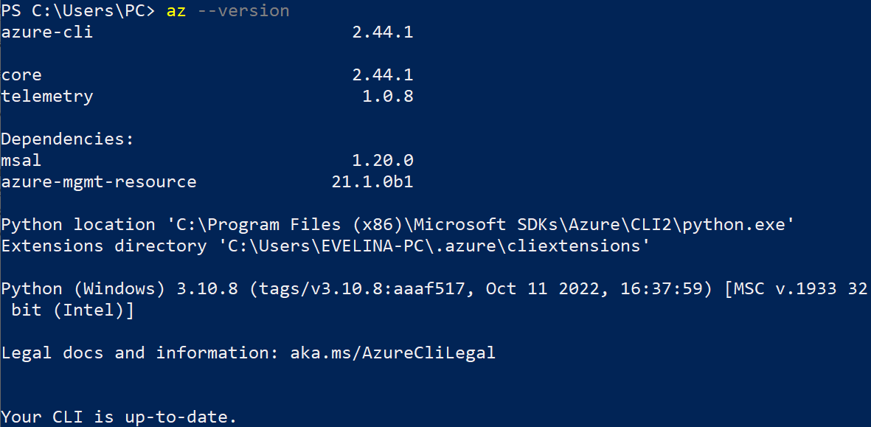

Now you can go on with **creating a container image**.

### Step 1: Create a Container Image for Deployment

In this step, you will **package the** "Tracker App" **into a container image** that can be **run** **using** AzureContainerInstances.

You are provided with a Dockerfile, so you should just **create the image**, for example "tracker-app-image". You should know how to do it:

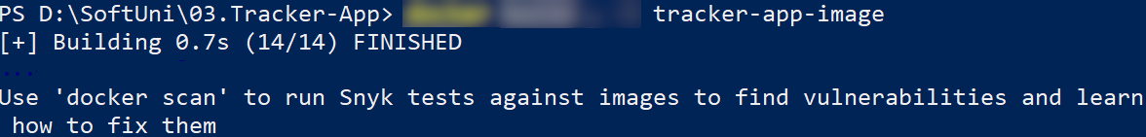

The **newly created image** should appear:



You can now use this **image to run a container locally** to see if it works:



↓

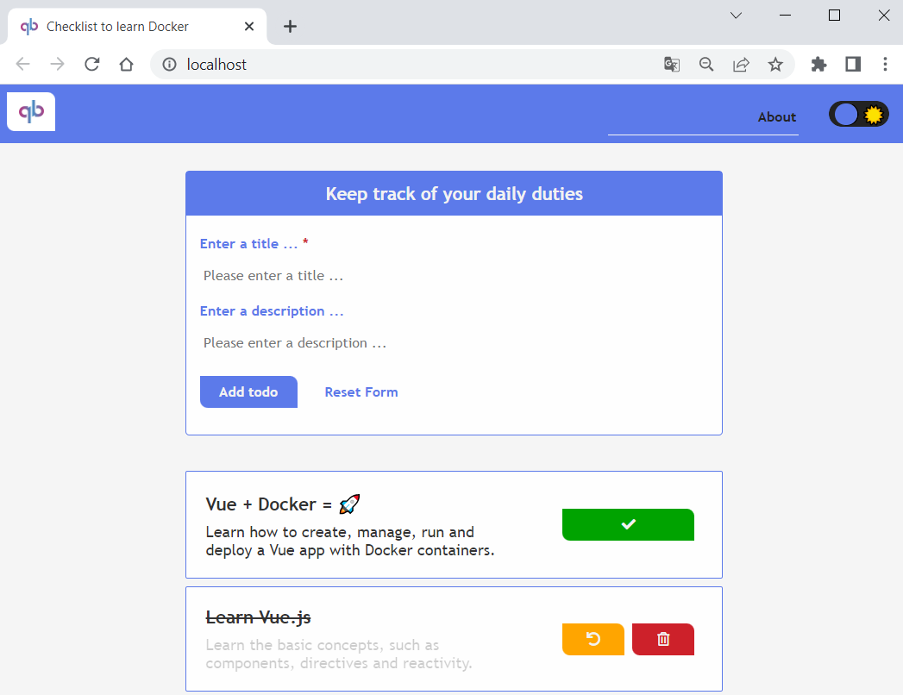

We have verified that the **container image runs locally**, so let's see how to **push it to** AzureContainerRegistry.

### Step 2: Create an Azure Container Registry and Push a Container Image

An Azure Container Registry is a **managed registry service**. It stores and manages **private container images** and other artifacts, similar to the way Docker Hub **stores public Docker container images**.

Now we should **create an** Azure **container registry** and **push our image** to it.

First, **login to** Azure through Azure CLI with the az login **command**. A **web browser will be opened** and you should **enter your credentials**. Then **login** should be successful:

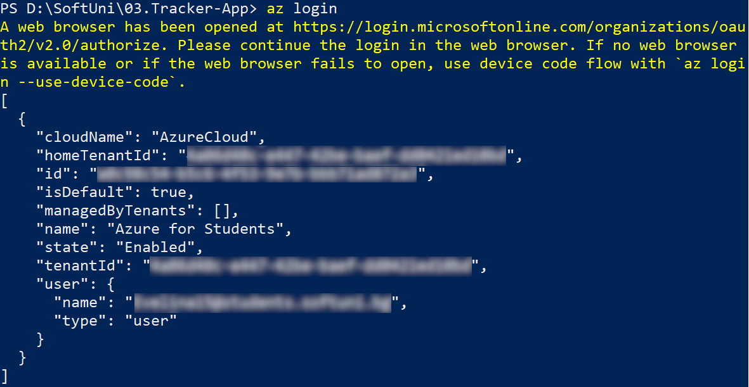

#### Create Azure Container Registry

Now you need a **resource group** to **deploy the container registry** that we will create to.

**Create a new resource group** in Azure with the az group create command. **Name the group** in a way you want and set it in the "westeurope" **region**:

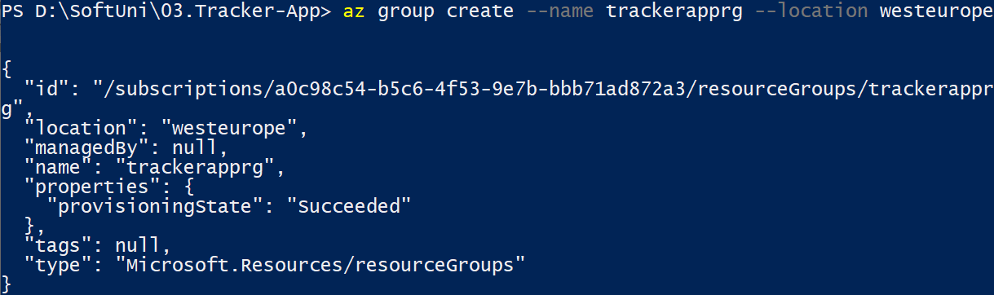

Once you've created the resource group, **create an Azure container registry** with the az acr create command. The **container registry name** must be **unique within Azure**, and contain **5-50 alphanumeric characters**:

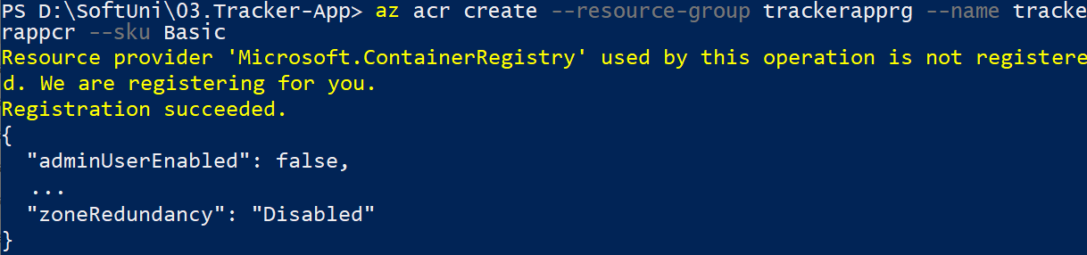

You can also **see the container registry** in Azure Portal by going to the "Container Registries" **page**:

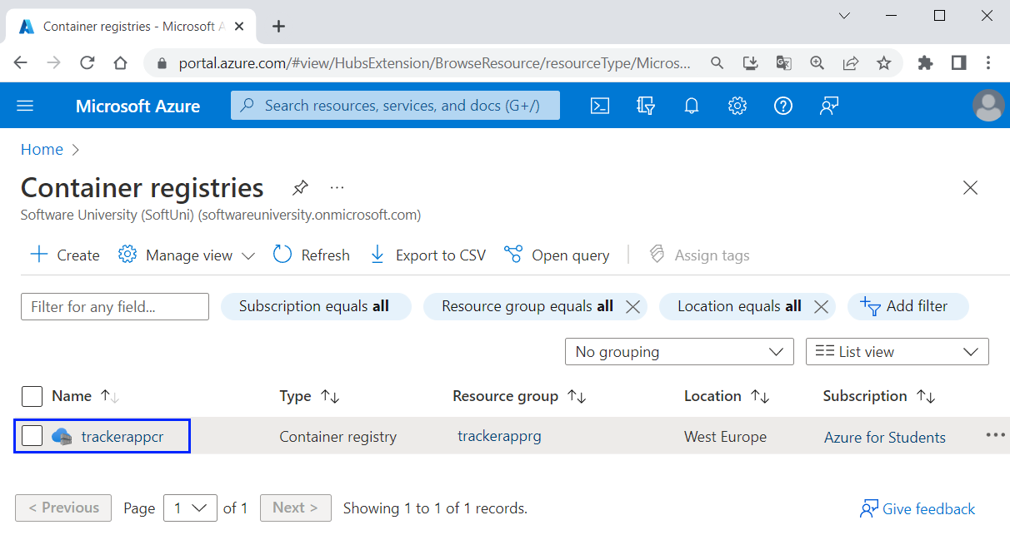

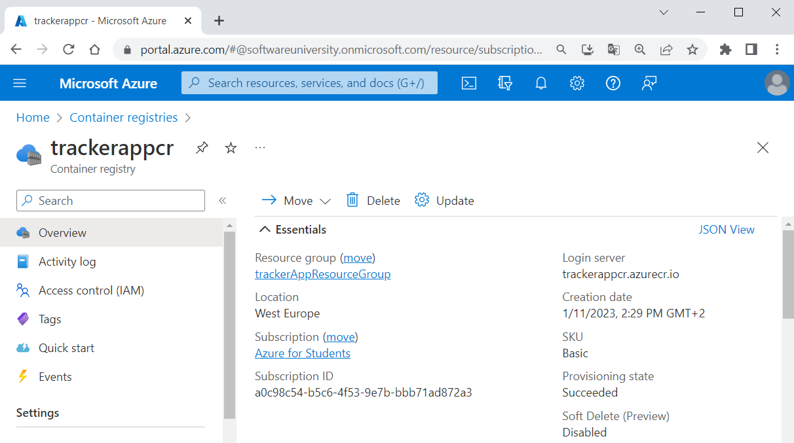

Next, you need to **log in to the container registry** you created, so that you can **push images** to it. You should use the az acr login **command** and **provide the name of the registry** you created:



Login should be **successful**.

#### Tag Container Image

To **push a container image** to a **private registry** like Azure Container Registry, you must first **tag the image** with the **full name of the registry's login server**.

Get the **full login server name** for your **Azure container registry**:

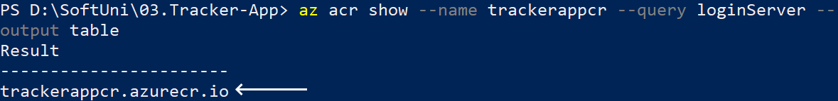

Now you should **tag the container image** we created in the previous step with the **login server of your container registry**. Also, add the :v1 **tag** to the **end of the image name** to indicate the **image version number**. Do it like this:

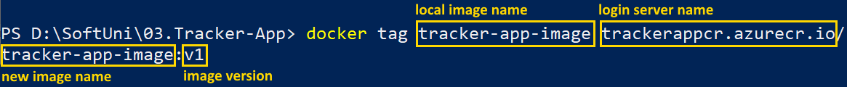

You can look and see that the **new image is created**:

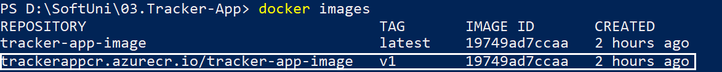

Now you **have your image**.

#### Push image to Azure Container Registry

Now you can finally **push your new image** to Azure Container Registry. Do it as shown below:

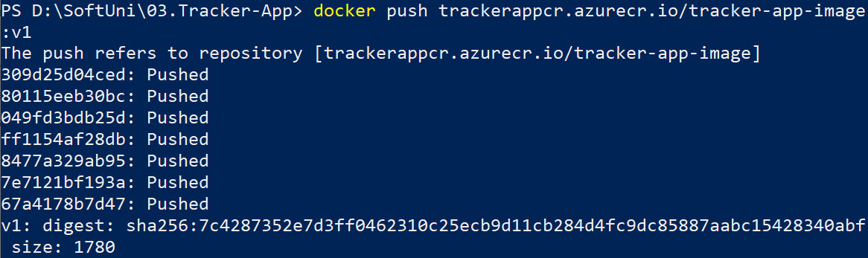

Your **image should be pushed successfully**. To verify this, **list the images** in your **container registry**:

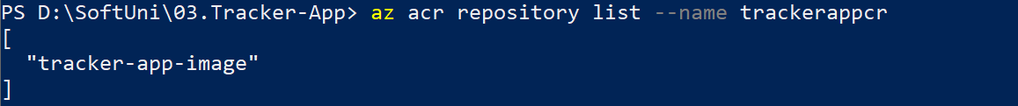

You have you **image in** Azure Container Registry. You can also **check in** AzurePortal when you select the **container registry** 🡪 [Repositories]:

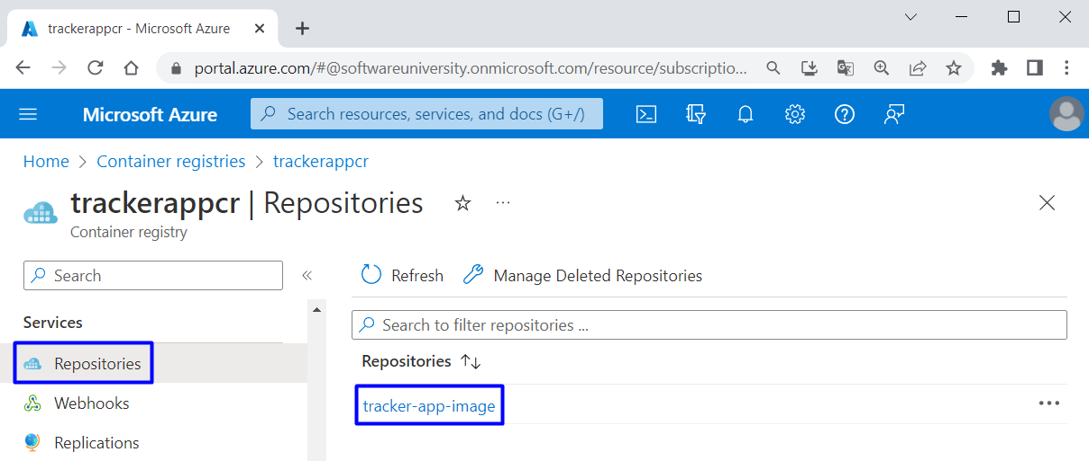

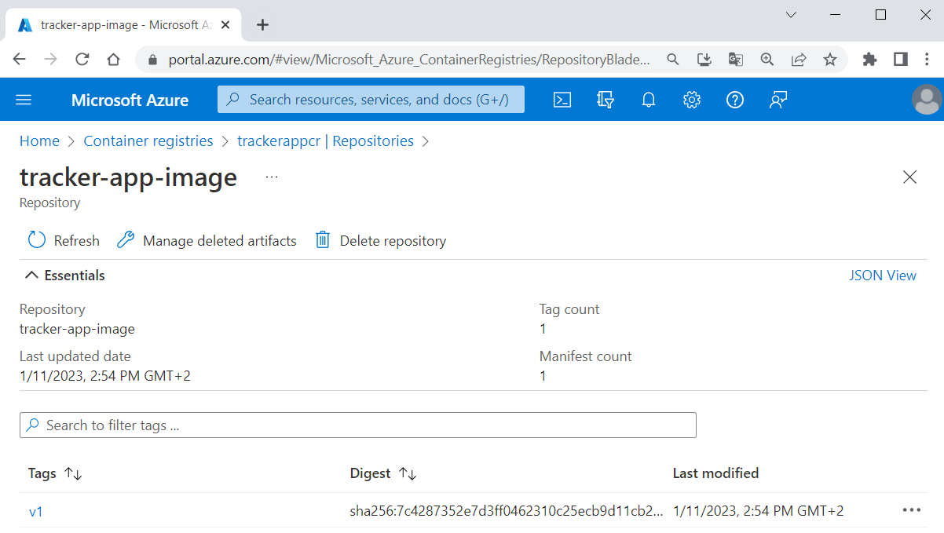

In this step you **prepared an Azure container registry** for use with Azure Container Instances, and **pushed a container image** to the registry.

### Step 3: Deploy a Container Application

Finally, we have everything needed to **deploy a container to** Azure Container Instances.

#### Get Registry Credentials

When you **deploy an image** that's **hosted in a private Azure container registry** like the one created, you must **supply credentials** to access the registry. For this to happen, you shall **create and configure** an Azure Active Directory (AD) **service principal** with pull **permissions** to your **registry**.

To do this, you will need the **following commands**:

|  |
| --- |
| $ACR_NAME='$containerRegistry'  $SERVICE_PRINCIPAL_NAME='$servicePrincipal'  *# Obtain the full registry ID*  $ACR_REGISTRY_ID=$(az acr show --name $ACR_NAME --query "id" --output tsv)  *# Create and configure the service principal with pull permissions to your registry*  $PASSWORD=$(az ad sp create-for-rbac --name $SERVICE_PRINCIPAL_NAME --scopes $ACR_REGISTRY_ID --role acrpull --query "password" --output tsv)  $USER_NAME=$(az ad sp list --display-name $SERVICE_PRINCIPAL_NAME --query "[].appId" --output tsv)  *# Output the service principal's credentials*  echo "Service principal ID: $USER_NAME"  echo "Service principal password: $PASSWORD" |

You should **modify them** for your environment:

* ACR_NAME should keep the **name of your Azure container registry**, which you already created
* SERVICE_PRINCIPAL_NAME should keep a **new name for your service principal**, which should be unique within your Active Directory tenant

**Execute the commands** one by one with the changes:

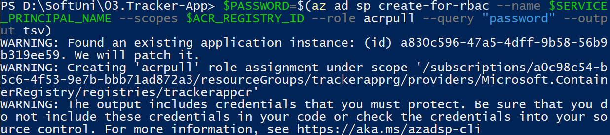  

You should **have no errors** and finally you should have your **service principal id** **and** **password**. Once you have these **credentials**, you can **configure your applications and services** to authenticate to your container registry as the service principal. **Copy them** because you will need them.

**NOTE:** If you get the "**Insufficient privileges to complete the operation.**" error message, go to "Container registries" in the **Azure Portal** and select the **trackerapp** container registry**:**

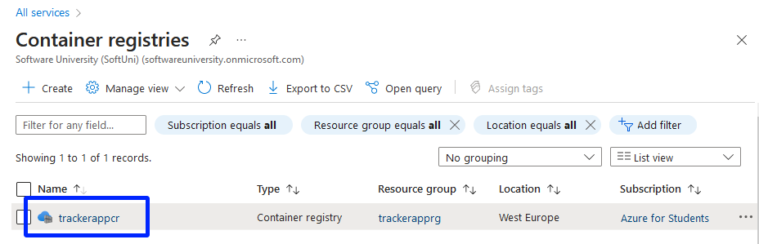

After that, select **Access keys** and enable the **Admin user:**

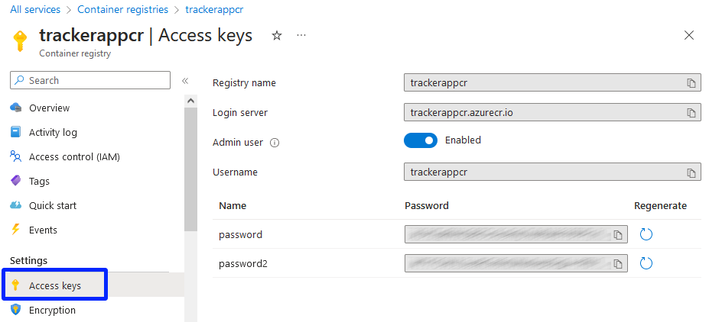

#### Deploy Container

Now use the az container create **command** to **deploy a container in Azure**. Use this command and **replace** <resource-group-name>, <image-name>, <acrLoginServer>, <service-principal-ID> and <service-principal-password> with **your corresponding values**. Also, **replace** <container-name> with a **name for your container** and <aciDnsLabel> with a **new DNS name** that you like:

|  |
| --- |
| az container create --resource-group <resource-group-name> --name <container-name> --image <acrLoginServer>/<image-name>:v1 --cpu 1 --memory 1 --registry-login-server <acrLoginServer> --registry-username <service-principal-ID> --registry-password <service-principal-password> --ip-address Public --dns-name-label <aciDnsLabel> --ports 80 |

**NOTE:** If you have enabled the **Admin user** in the previous step, just replace **<service-principal-ID> with <username>** and **<service-principal-password>** with **<password>**

**Container deployment** should be **successful**:

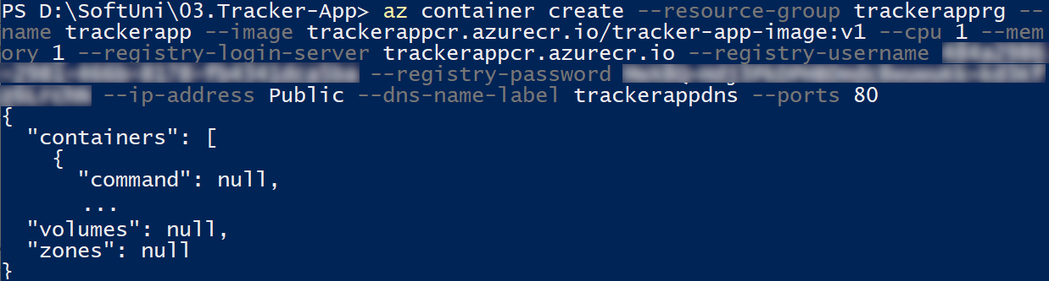

To **view the container state** **of deployment**, use:



Once the **deployment succeeds**, display the **container's fully qualified domain name** (FQDN):



Use the FQDN to **access your app in the browser** (it contains the **DNS** **label** you chose):

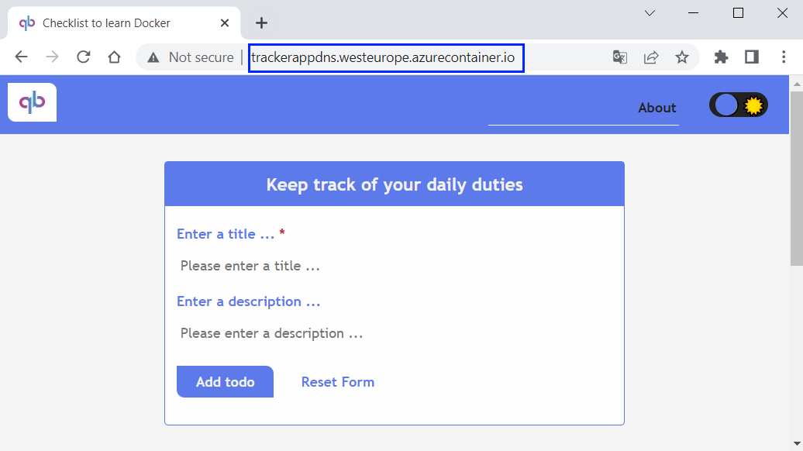

It should be **fully working**.

#### Explore and Remove Container

You can look at the **created container instance** in Azure Portal too:

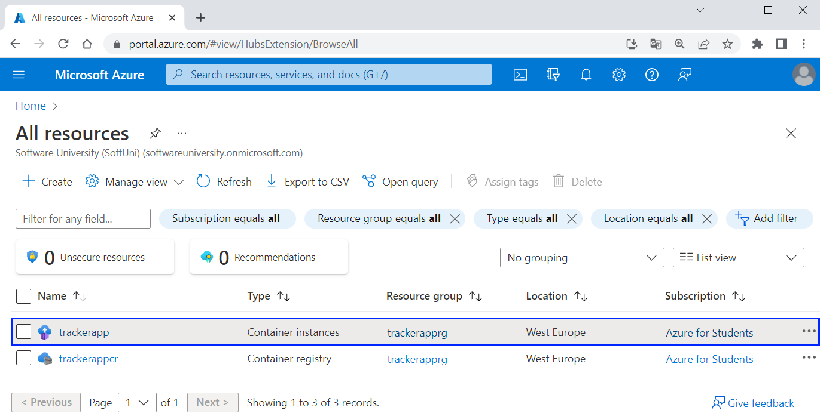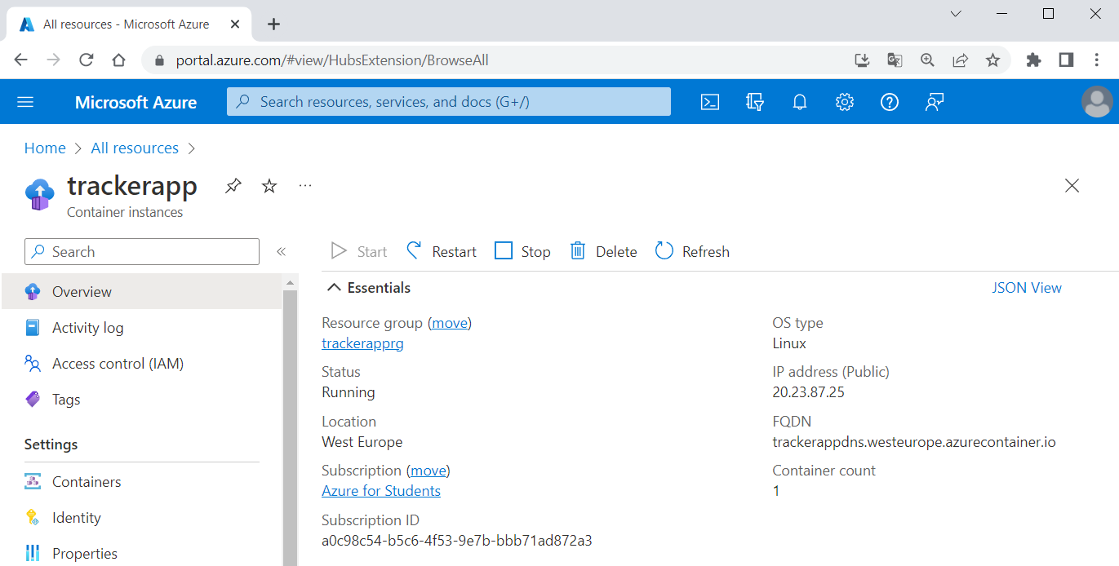

You can also view the **log output of the container** from Azure CLI:

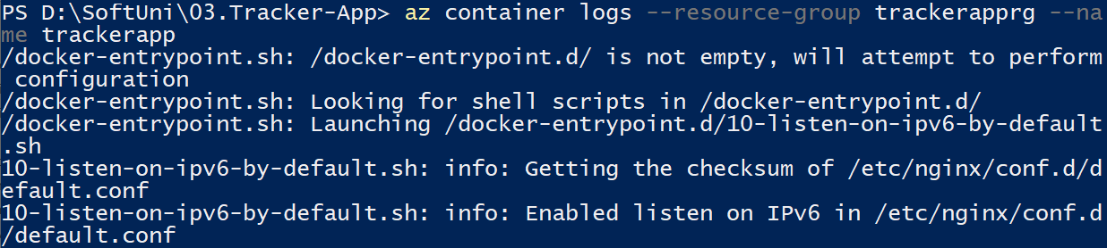

And finally, **clear all resources** by **deleting the resource group** with az group delete:



Now we know how to **create resource groups**, **container registries**, **container instances**, etc. and **deploy a container app** in Azure.

## Deploy the "TaskBoard" App using Docker Compose

In this task, we will **deploy** the TaskBoard **multi-container app** as a **container group** in Azure Container Instances, using Docker Compose. This is a way to easily switch from local to cloud deployment.

When successfully **deployed to Azure**, the app will look like this on its **provided IP address**:

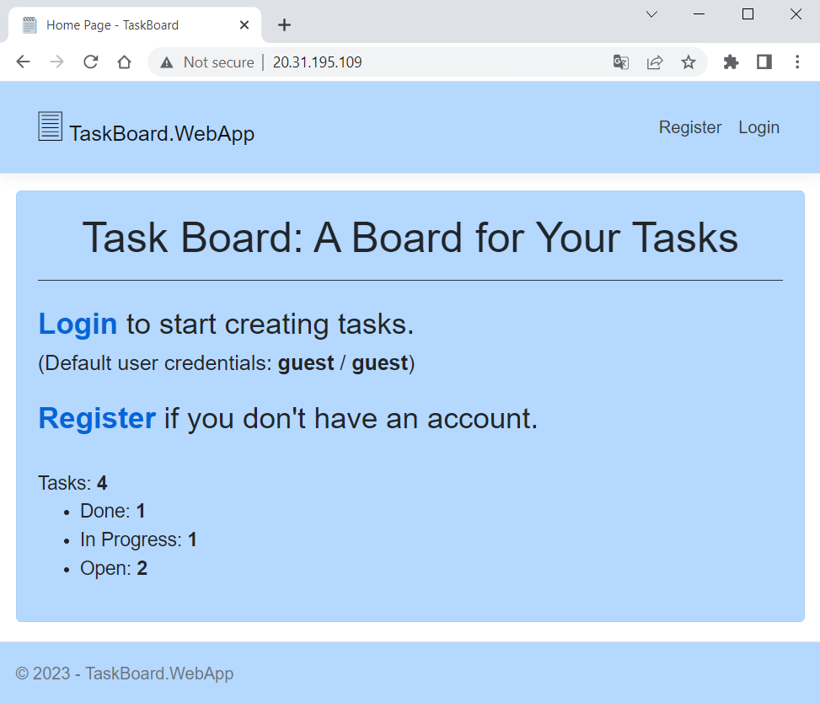

You have the TaskBoard **app** with a docker-compose.yaml **file** for it in the **resources**:

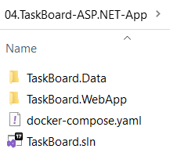 🡪

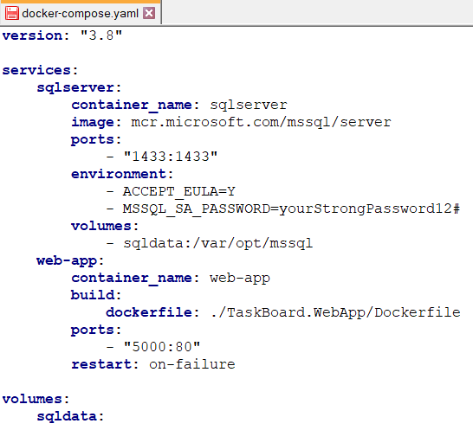

To create and use a **volume** **in** **Azure**, we will use the Azure File Share **service**. As you can see, **we haven't defined a custom network**, as **Azure will create a default one**. If you want, however, you can search and create a **custom network in Azure** for your containers.

Let's see how to **deploy the app** in ACI.

### Step 1: Create Azure Container Registry

The first thing we should do is to **create a container registry** in Azure, using the CLI. We will **create a resource group** named "taskBoardResourceGroup" and a **container registry** with name "taskboardcr". You can do this by yourself:

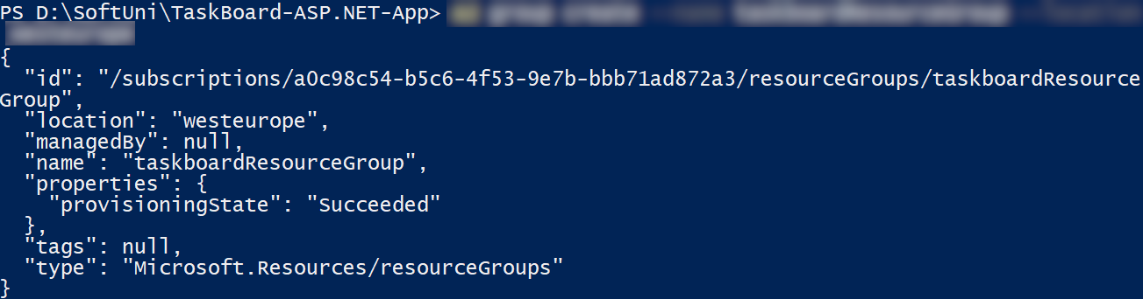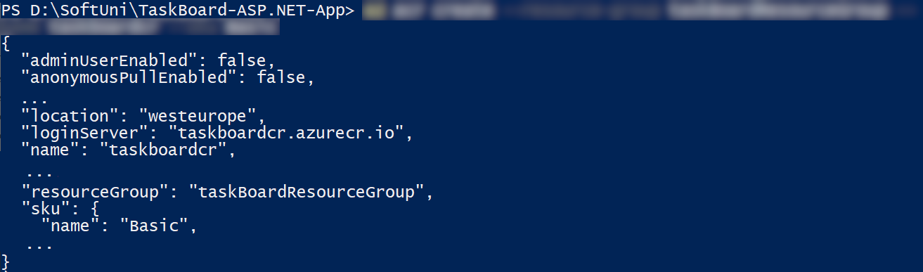

You can also look at them in Azure Portal:

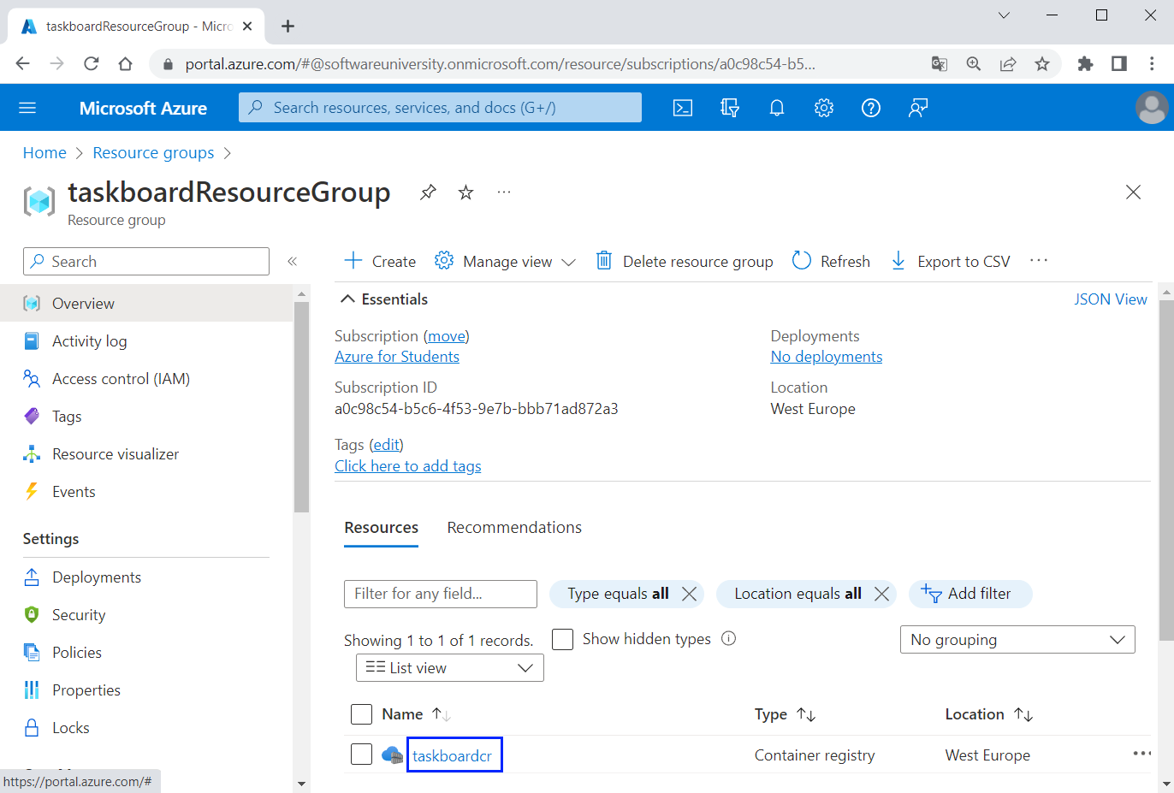

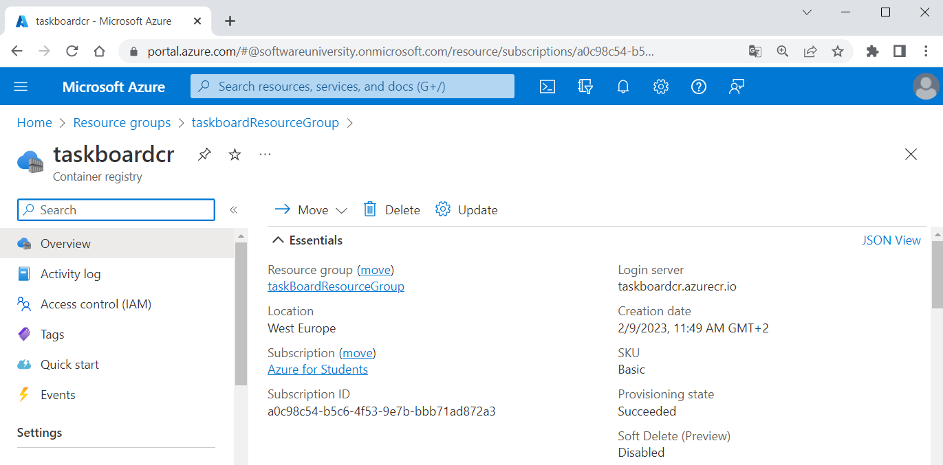

Then you should **log in** to the taskboardcr **container registry** that you have just created:



### Step 2: Modify Docker Compose File

Now you should make some **modifications to the provided** docker-compose.yaml **file**, so that it works in **Azure** later.

First, you should make sure that in **each container** the **default container port** and the **exposed port are the same**:

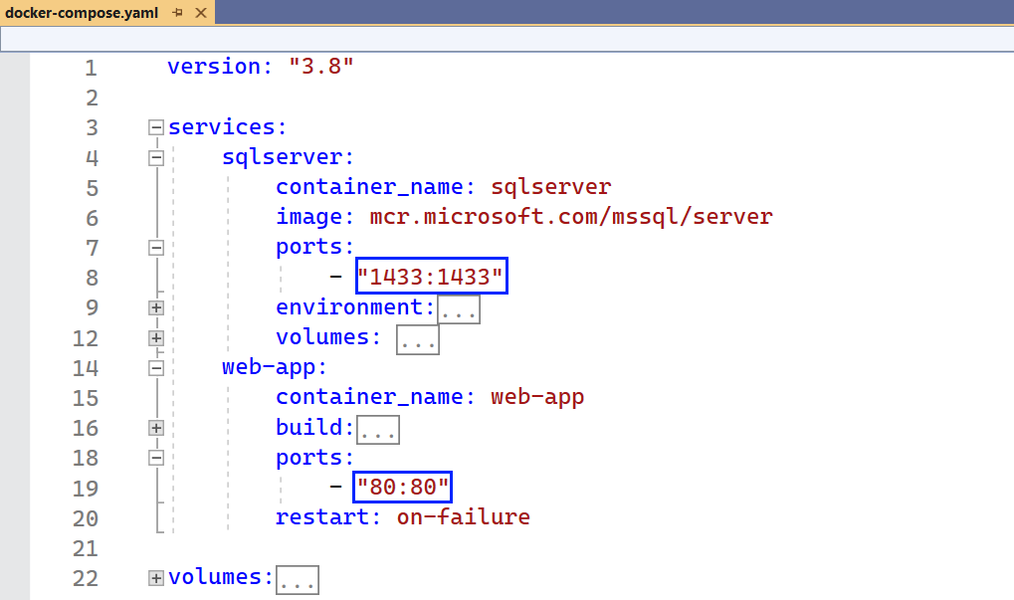

This is because **port mapping** is **not supported** with **ACI**.

Next, you should **add an image property** to the web-app **service**. It should **contain the login service name** of your container registry (taskboardcr.azurecr.io) + / + **your image name**:

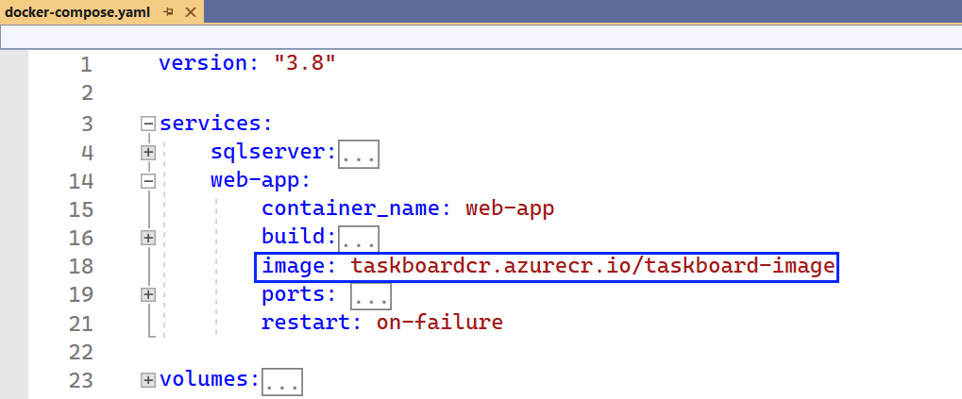

These were the **changes** we needed to make for now. Because of these changes, the taskboard-image will be **tagged** for your **Azure** **container** **registry** on the next step. Then it can be **pulled to run in Azure Container Instances**.

Finally, you should **set deployment options** for **resources to be reserved** for the sqlserver container:

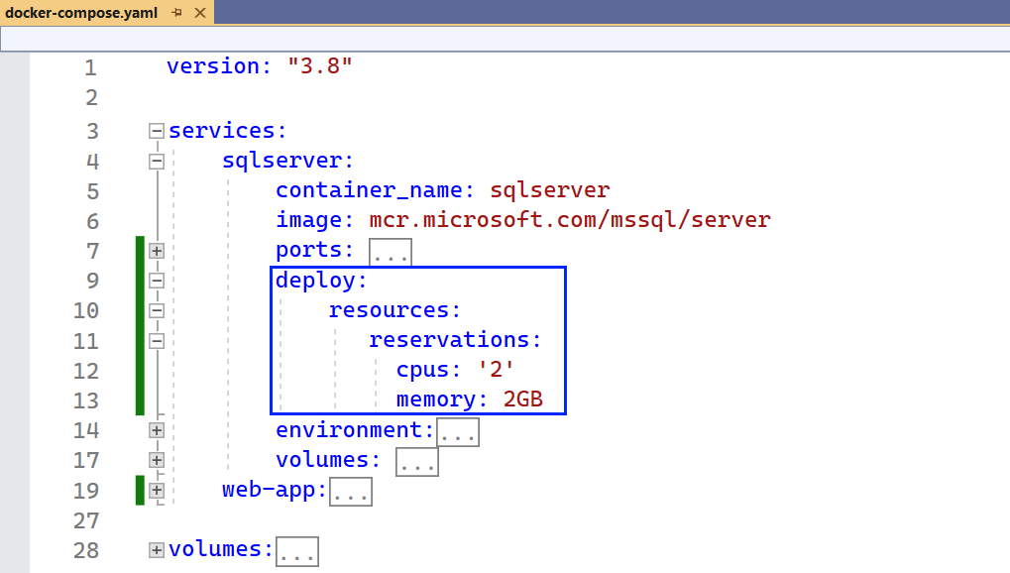

The SQL **container** needs **2 CPU** and **2GB memory** at least to work properly. If it is **missing resources**, it would not be able to **create all database tables** it needs and this would result in **errors**.

**NOTE:** it is important to know that **services names** should contain only lowercase letters, numbers and hyphens and the **password** should not contain symbols like "**$**". If you have **any problems** with the docker-compose up **command** later, **return to this step** and think about a **possible problem** in the docker-compose.yaml **file**.

### Step 3: Run Multi-Container App Locally

Use the docker-compose.yaml **file** we modified to **build the container image** and **start the** TaskBoard **application** **locally**:

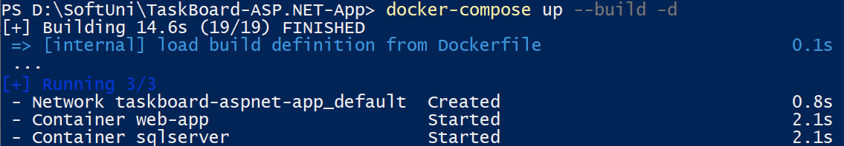

When completed, you will have the **Docker containers** and the **tagged** web-app **service image**:

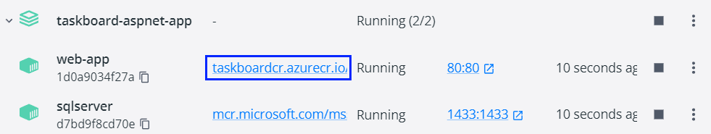



Make sure that the **app is working correctly** with the database:

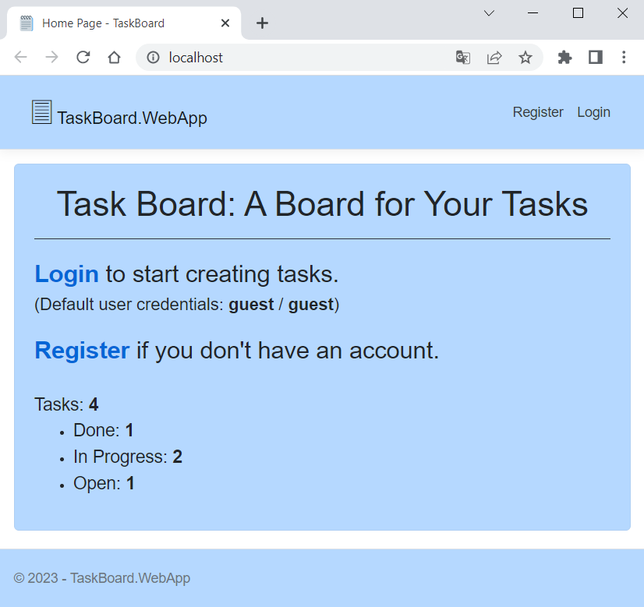

Then you can **stop the app** and **remove the containers**.

You can see in Docker that we have the **container image** and it is **tagged:**

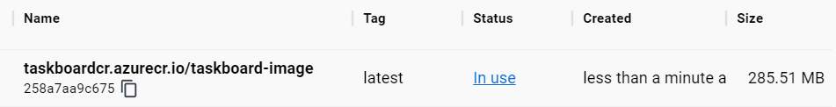

So now we should **push it to our Azure container registry**. Use the docker-compose push command and the **image should be available in the registry**:

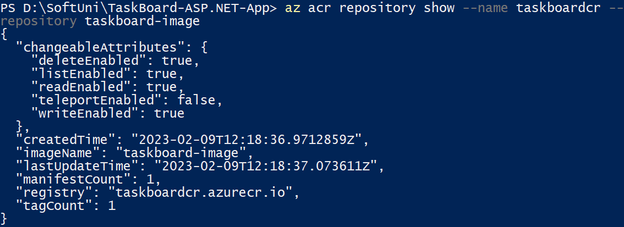

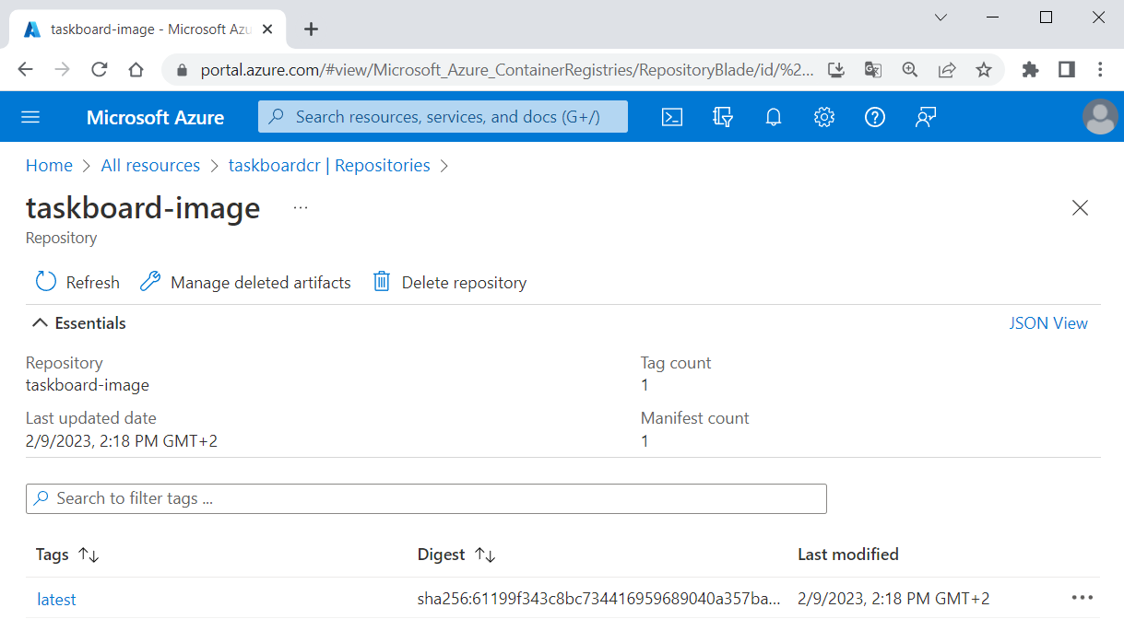

Later we will **use this image**.

### Step 4: Set up Azure File Share Storage

As you know, a **SQL Server container** needs a **volume to persist data**. Azure File Share is used to support **volumes** for ACI **containers**. We should **create a file share** and use it in our docker-compose.yaml **file**.

**Azure file shares** are deployed into **storage accounts**. An Azure storage account contains all of your Azure Storage **data objects**: blobs, files, queues, and tables. Azure supports multiple types of storage accounts.

**Azure** can create a **file share** by itself when you add it in the Docker Compose **file**. **Mount the volume** to the SQL Server container's **directory** and **specify the volume driver** (azure_file) and its **options** (**file share** and **storage account names**) like this:

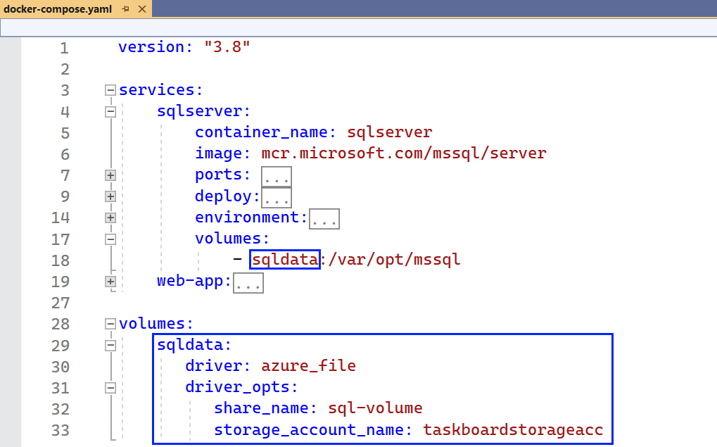

We set the **name of the volume** to "sql-volume" and the **storage account name** to "taskboardstorageacc" but you can **use different names**.

Your app is **fully prepared** for **deployment to ACI**.

### Step 5: Create Azure Context

You should **create an ACI context** to associate **Docker with an Azure subscription** **and resource group** so you can **create and manage container instances**. You know how to **create a context**, so create the taskboardcontext aci **context** in the taskBoardResourceGroup **resource group** by yourself:

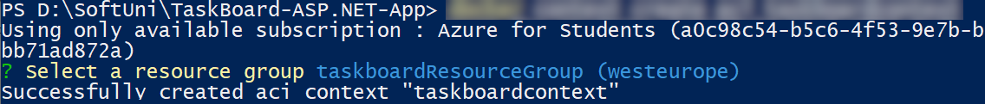

Then use the **created context**:



This will make the **subsequent commands executed in this context**, e.g., in **Azure**.

### Step 6: Deploy App to Azure Container Instances

Finally, you should **run the** dockercomposeup **command** in the aci **context** to **start the application in** Azure ContainerInstances:

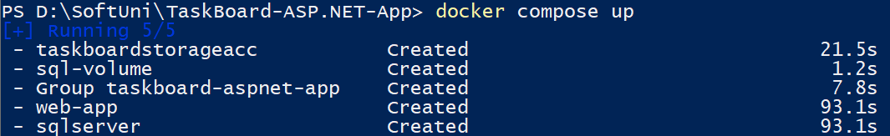

The taskboard-image **image** will be **pulled from your container registry**. After a while, **storage account** and **file share are created** and will be used for **volume** in the container. Then, **containers are deployed as a group** **in** ACI.

**NOTE:** if **any errors occur** or the **command does not run the containers**, think about what you may have done wrong in the previous steps. Especially, you may have **problems with your** docker-compose.yaml **file**. Try to solve the problems and **run the app in Azure successfully**.

To see the **running containers** and the **IP address** assigned to the **container group**, execute the following command:



You can also look at them in Azure Portal:

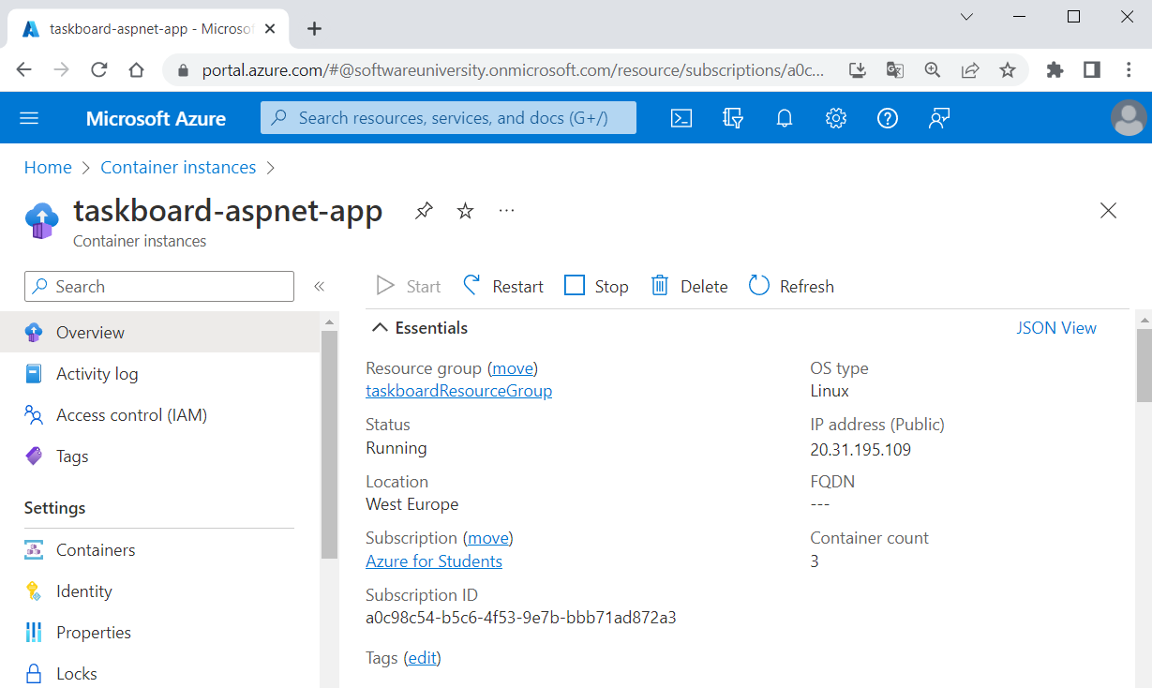

You can also look at **each container's logs** in [Settings] 🡪 [Containers].

And here are the **storage account** and the **file share** that were created:

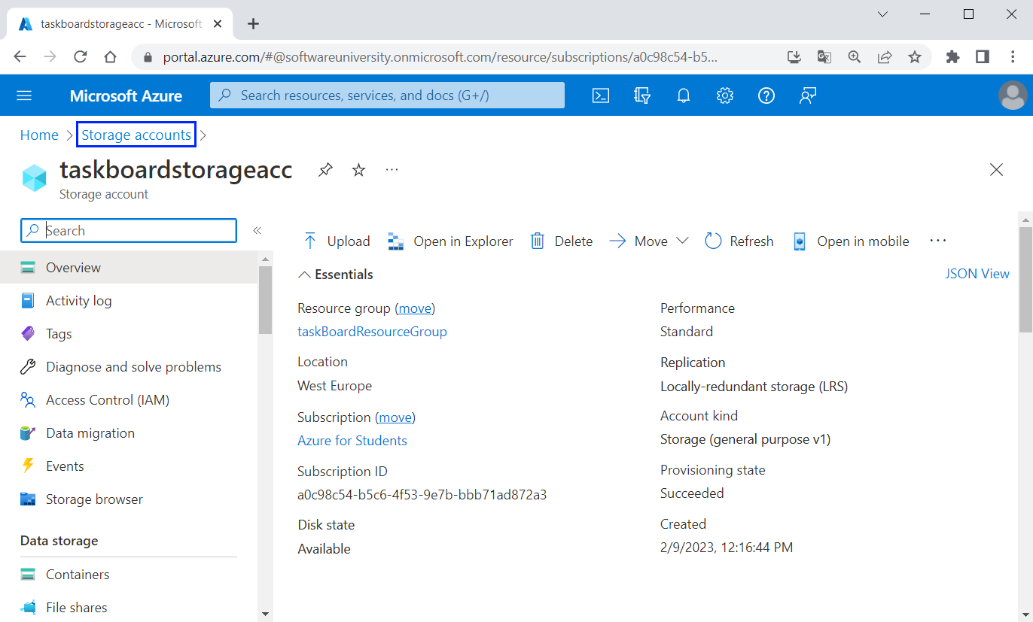

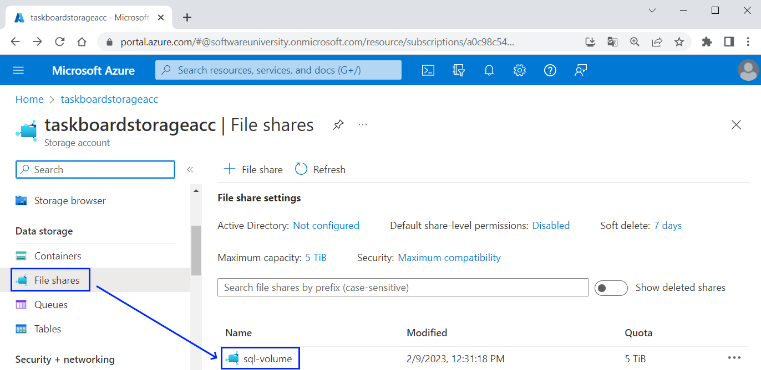

### Step 7: Run the App in Azure

At the end, use the **IP address of the app** to **navigate to it**. Wait for **several minutes**, **refresh the browser** several times and your TaskBoard **app** should be **up and working**:

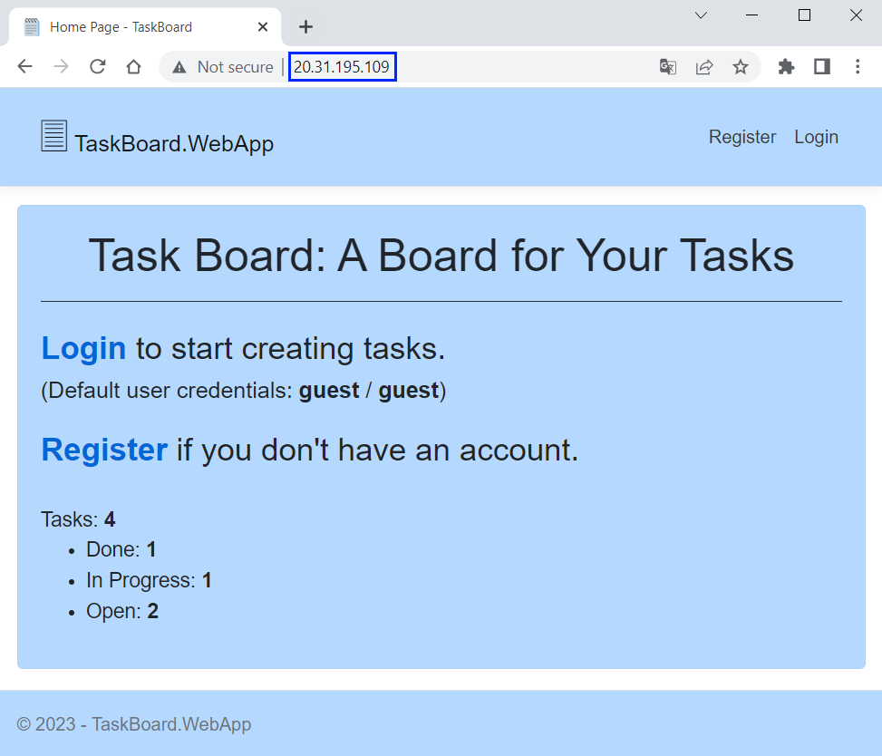

**NOTE**: you may have **multiple errors in the container logs** because the **SQL database** **takes time to be created** and the **web app fails to connect to it** several times. However, if this **behavior doesn't stop** or **any of your containers is terminated**, then you should **search for a problem with the app or its deployment**.

## Deploy the "Posio" App

Here is one more task for you to try and **deploy a simple app** to Azure Container Instances using a Docker Compose **file**. The "Posio" **app** is a **simple multiplayer geography game** using Websockets. You have it in the **resources** and it should look like this when **deployed**:

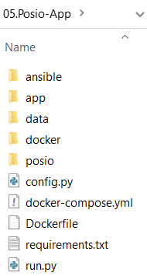 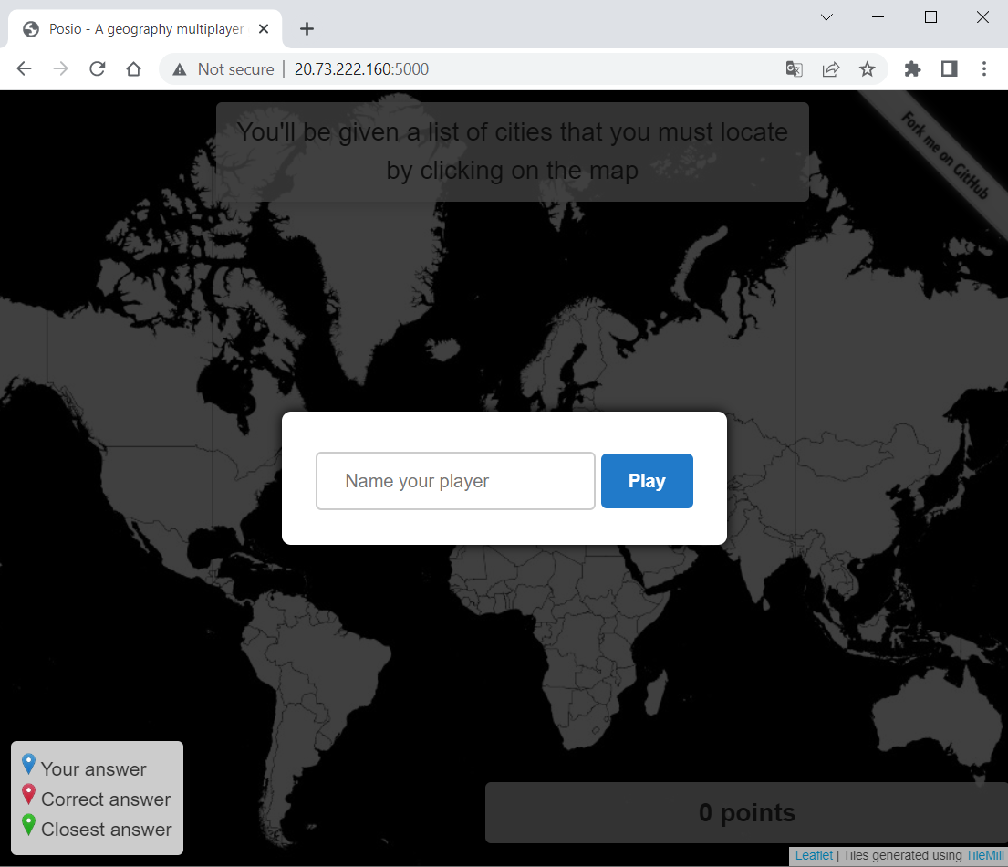

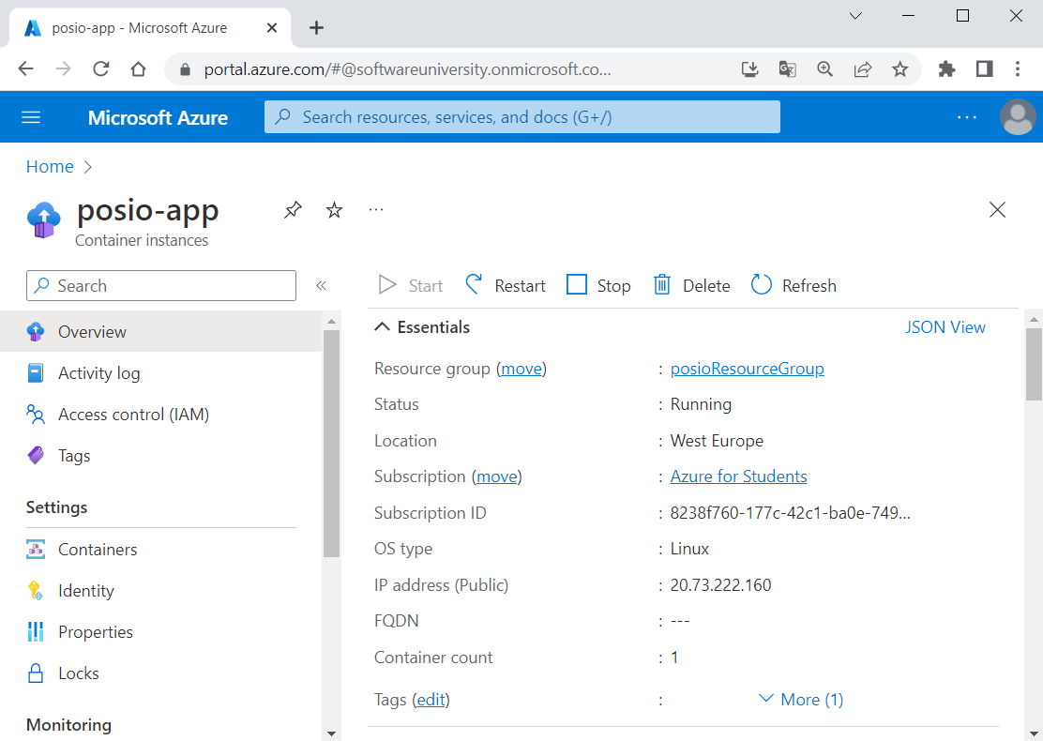

To **deploy the app**, follow the steps from the **previous task**: create a container registry and push the app image, set up a file share to be created, create context and deploy the app to ACI.

When done, the **app should be accessed** on {IP Address}:5000 and you should be able to **play the game**:

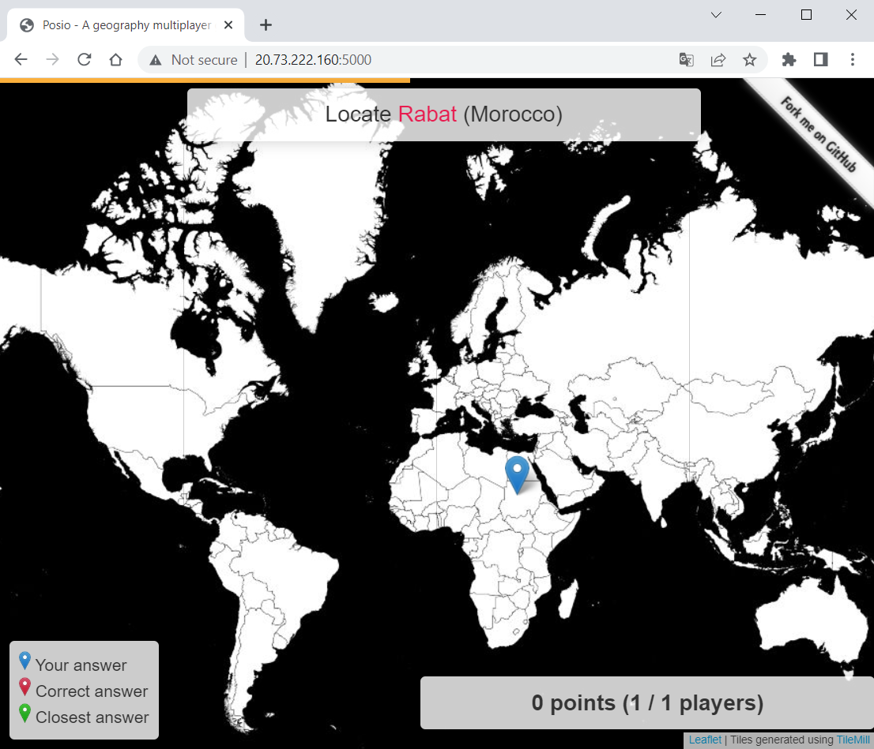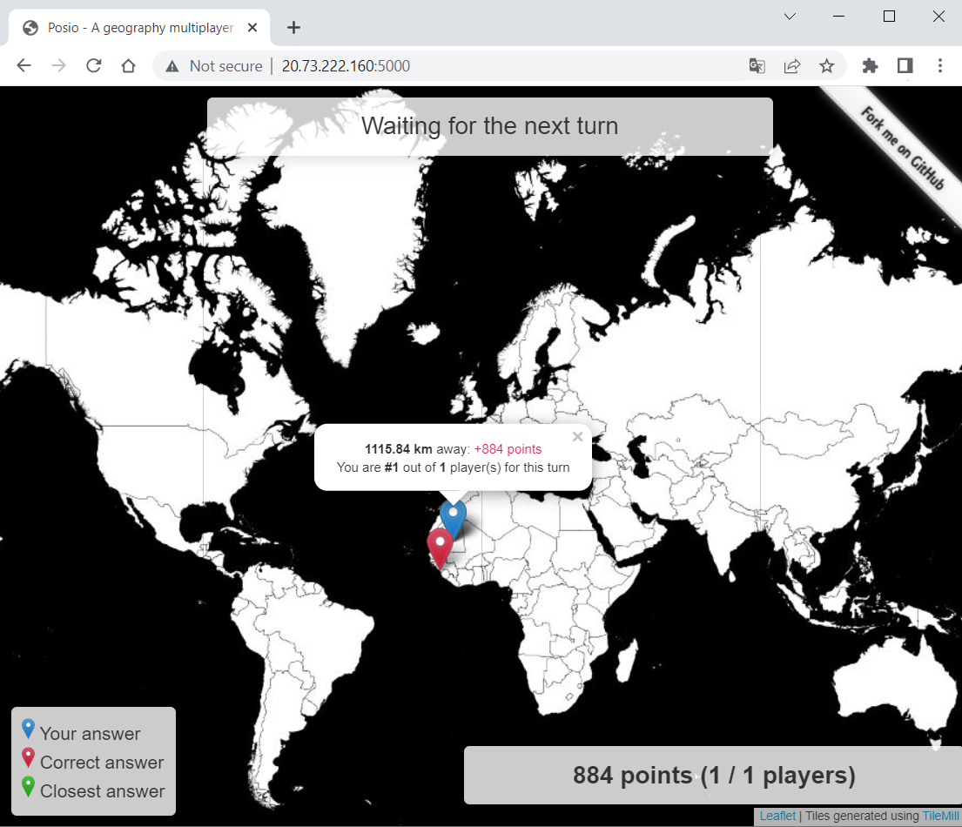

You can play with friends – there is a **rank of players**.